 Setup Guide: Creating SharePoint 2010 Development Virtual Machine with Hyper-V

**Estimated Time for Completion**: 4 Hours

**Overview:** This document provides links to Internet resources and step by step instructions for building a Virtual Machine (VM) for development with SharePoint Server 2010. This VM can be used to complete the lab exercises for Critical Path Training SharePoint 2010 development courses and also for general development with SharePoint 2010.

Note that the requirements for building out a SharePoint 2010 development environment are more relaxed and have fewer requirements compared to building out a SharePoint 2010 production environment. Therefore, you should not rely on this document as your only resource when you are installing SharePoint 2010 for production use.

This setup guide assumes you will build your VM using Microsoft’s trial software. Therefore, you will not require you to supply your own product keys for Windows Server 2008 R2 or SQL Server 2008 Enterprise. You will begin by downloading the trial *.VHD file for Microsoft’s evaluation VM for Windows Server 2008 R2 and you will use this as a starting point.

Table of Contents

Step 1: Verify Requirements for Building the Virtual Machine 1

Step 2: Download and Configure the Windows Server 2008 R2 Evaluation VM 2

Step 3: Configuring Active Directory 10

Step 4: Configuring Windows Update 14

Step 5: Install SQL Server 2008 Enterprise 15

Step 6: Install and Configure SharePoint Server 2010 Beta 2 23

Step 7: Creating a new Web Application at http://intranet.wingtip.com 32

Step 8: Install the Microsoft Office Professional Plus 2010 Beta 39

Step 9: Install the beta for Visual Studio 2010 Ultimate 42

## Step 1: Verify Requirements for Building the Virtual Machine

Before you begin, make sure that host computer meets the requirements outline below.

1. Your computer hardware and software must meet the following requirements.
   1. Your computer is running a 64-bit installation of Windows Server 2008 R2
   2. Your computer has a connection to the Internet
   3. Your computer has at least 6GB of RAM (8GB recommended)
   4. Your computer has at least 80GB of free disk space.
   5. Your computer supports virtualization and has Hyper-V Services enabled.
   6. Hyper-V Services is configured with a Virtual Network which is connected to the Internet. In this lab, it is assumed that this virtual network is named **HostLanCard**.
   7. Your host machine has a network share accessible to the VM. The share will be used as a download location for installation files that will be used to install software on the VM.
   8. If you need more information on how to install and configure Hyper-V, you can read more at [http://www.microsoft.com/windowsserver2008/virtualization/install.mspx](http://intranet.wingtip.com).

*This guide walks you through how to setup a virtual machine using Microsoft’s Hyper-V virtualization product that’s part of Windows Server 2008 & Windows Server 2008 R2. While there are other virtualization products available to developers, this guide only covers Hyper-V. However, most of the steps in this guide can be applied to creating a virtual machine with other virtualization products such as VMWare Workstation or VirtualBox.*

## Step 2: Download and Configure the Windows Server 2008 R2 Evaluation VM

In this step you will download Microsoft’s free evaluation VM for Windows Server 2008 R2 Enterprise (Full Edition). This VM will serve as a starting point for building out a SharePoint development environment.

1. Download the trial VHD for the **Windows Server 2008 R2 Enterprise Evaluation** from the URL below. Make sure you download the **Full Edition** instead of the **Server Core** edition.

[http://www.microsoft.com/downloads/details.aspx?FamilyId=9040a4be-c3cf-44a5-9052-a70314452305&displaylang=en](http://intanet.wingtip.com?FamilyId=9040a4be-c3cf-44a5-9052-a70314452305&displaylang=en?FamilyId=9040a4be-c3cf-44a5-9052-a70314452305&displaylang=en)

After you have completed the download, you should have an EXE file on your local hard drive named **Windows Server 2008 R2 Enterprise Evaluation (Full Edition).exe**

1. Extract VM image from **Windows Server 2008 R2 Enterprise Evaluation (Full Edition).exe**
   1. Double click the EXE for to begin the extraction. This will extract the VHD file named **Windows Server 2008 R2 Enterprise Evaluation (Full Edition).vhd**.
   2. Rename the VHD file to **WingtipServer.vhd**
   3. Move or copy **WingtipServer.vhd** to the location on a local hard drive from which the Hyper-V service will run it.
2. Use The Hyper-V Manager to create a new Virtual Machine to run **WingtipServer.vhd**
   1. Launch the Hyper-V Manager from Administrative Tools
   2. Start the New Virtual Machine Wizard
   3. When the wizard prompts you for the machine name, enter **WingtipServer**.
   4. When the wizard prompts you to assign memory, enter **4092 MB** (4GB)
   5. When the wizard prompts you for a network connection, select **HostLanCard**
   6. When the wizard prompts you to **Connect Virtual Hard Disk**, choose **Use an existing virtual hard drive** and browse to select **WingtipServer.vhd**.

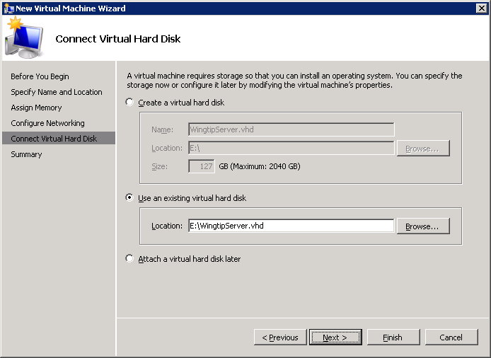

* 1. When you complete the New Virtual Machine Wizard as shown below, Click **Finish**.

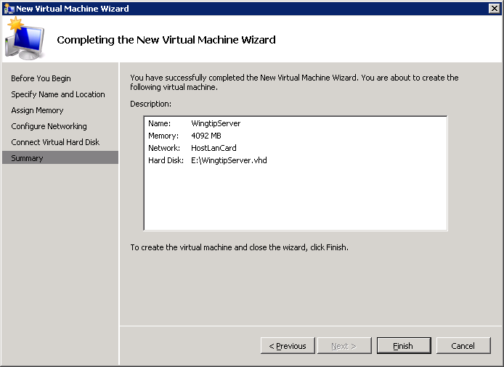

1. Configure and start the new VM
   1. Before starting the VM, inspect its settings page using Hyper-V Manager
   2. By default, the number of processors is set to 1. If your hardware supports multiple processors, increate the number of processors to the maximum number allowed.
   3. Now start the VM
   4. Connect to the VM through the Hyper-V console and wait for the boot process to complete.
2. First, disable the requirement to change Administrator password and change computer name.
   1. Login with User name of **Administrator** and password of **Pass@word1**.
      1. The virtual machine may or may not prompt you to restart it after logging in the first time. If prompted, go ahead and restart the VM. At this point the operating system is making some internal virtual hardware changes and needs to reboot in order to apply them.
   2. After you log in, Windows Server displays the **Initial Configuration Tasks** window. Click the check box with the caption **Do not show this window at logon** and then click the **Close** button. After you close this window, Windows Server will display the **Server Manager**. If the Server Manager is not open, launch it from the Windows Start menu using **Start > Administrative Tools > Server Manager**.
   3. In this step you will configure the Administrator account so that its password does not expire. Inside the **Configuration** node of the Server Manager, navigate the **Users** folder inside the **Local Users and Groups** node (as shown in the following screenshot) and locate the local **Administrator** account. Right-click on the **Administrator** account and click **Properties**.



* 1. In the **Administrator Properties** dialog, unselect the option for **User must change password at next logon** and select the option for **Password never expires**.

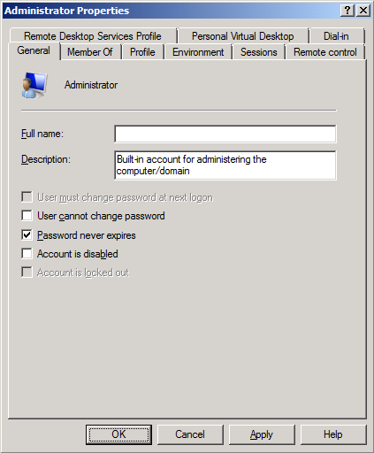

* 1. Now rename the computer name of the VM. In the Server Manager, navigate to the top-level node to display the **Server Summary** page. Click **Change System Properties**.

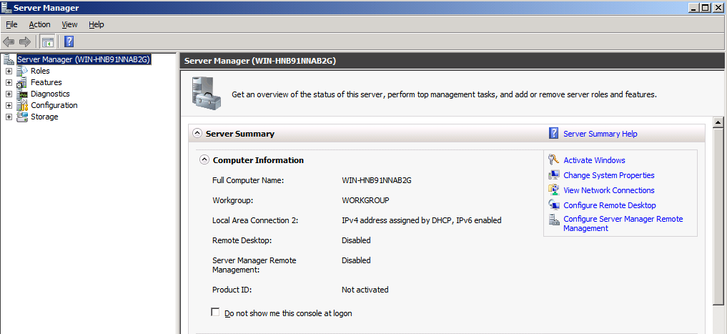

* 1. On the **Computer Name** tab of the System Properties dialog, click the **Change** button.

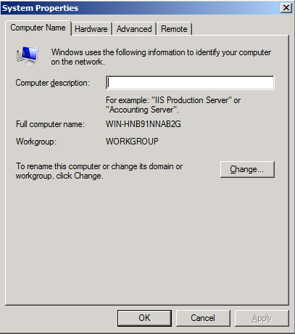

* 1. Enter a new computer name of **WingtipServer** and click OK. Note there is no need to change the Workgroup because later you are going to create a new domain.

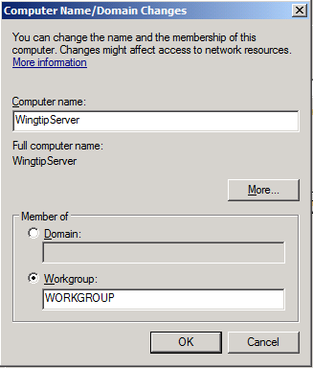

* 1. After changing the computer name you will be prompted to restart the VM. Choose **OK** to restart. After the VM has restarted, log in again using the same credentials as before.

1. Disable Windows Firewall and Enhanced Security Configuration
   1. In the Server Manager, navigate to the top-level node to display the **Server Summary** page. Inside the **Security Information** section locate the links for **Go to Windows Firewall** and **Configure IE ECS**.

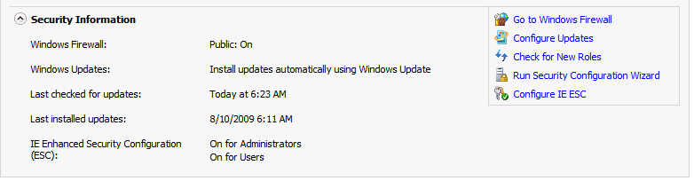

* 1. Click on Configure **IE ECS** link. Disable Enhanced Security Configuration for both Administrators and Users and click OK.

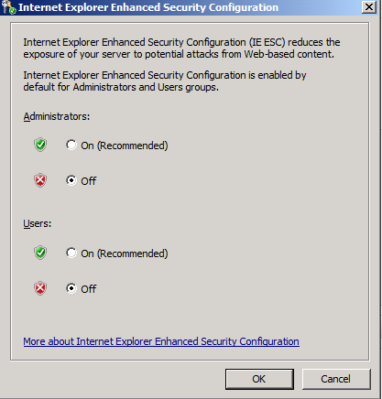

* 1. Now click the **Go to Windows Firewall** link to display the page for the Windows Firewall. Click on the **Windows Firewall Properties** link at the bottom of the **Overview** section.

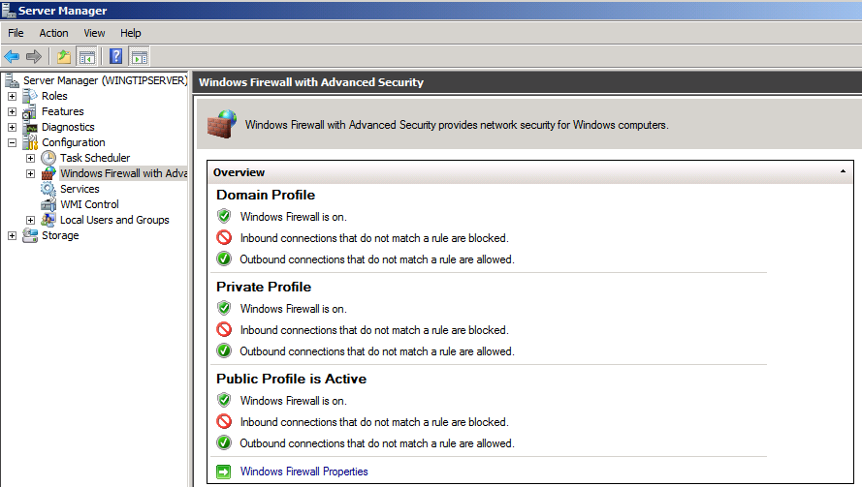

* 1. In the **Domain Profile** tab of the Windows Fire dialog, change the **Firewall state** property setting from **On** to **Off**. Click to **Apply** button to save your changes. Once you have turned off the firewall in the Domain Profile tab, go to the **Private profile** tab and the **Public profile** tab and follow the same steps to disable the firewall for these profiles as well. Click **OK** to dismiss the Windows Firewall dialog once you have turned off the firewall for all three profiles.

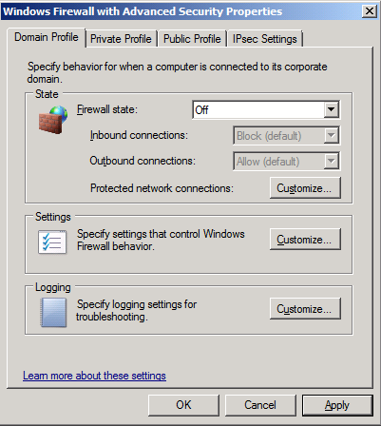

1. Enable the Windows Server Features for the **Desktop Experience** and the **PowerShell Integrated scripting environment**.
   1. In Server Manager, choose **Add Feature** to bring up the Add Features Wizard dialog.
   2. Select the feature **Desktop Experience**.

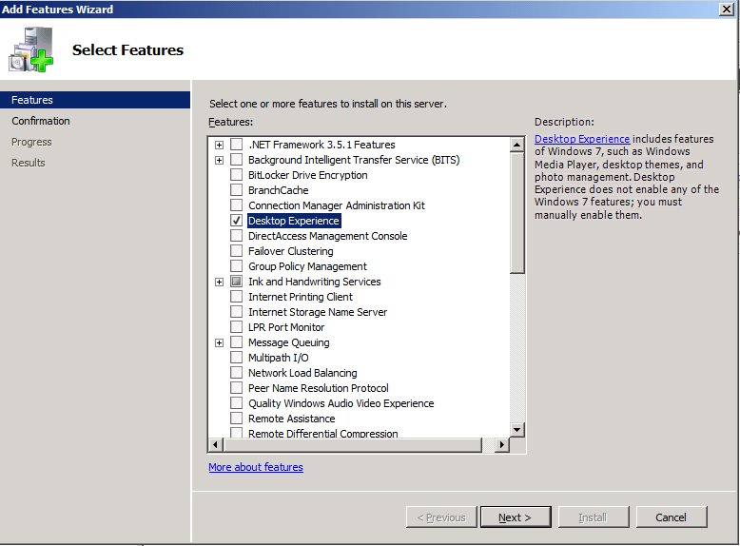

* 1. Note when you first click the checkbox for the **Desktop Experience**, the wizard will prompt you with the following dialog to add support for Ink and Handwriting Services. Click the **Add Required Features** button to continue.

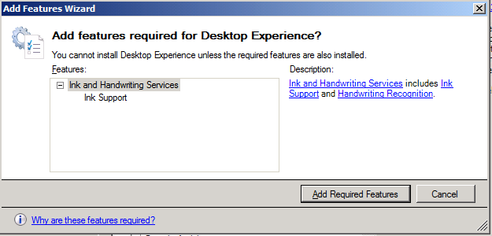

* 1. Scroll down the list of features in the **Add Features Wizard dialog** and select the feature **Windows PowerShell Integrated Scripting Environment (ISE)**.

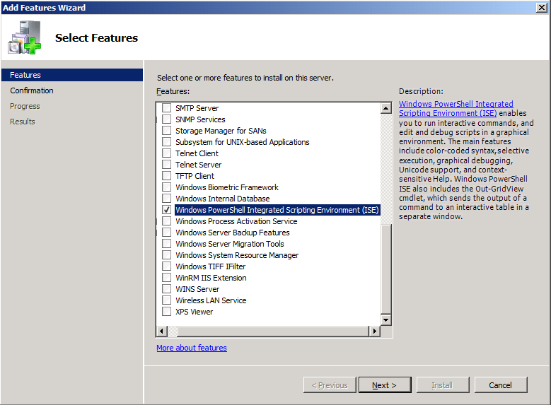

* 1. Note when you first click the checkbox for the **Windows PowerShell Integrated Scripting Environment (ISE)**, the wizard will prompt you with the following dialog to add support for .NET Framework 3.5.1 Features. Click the **Add Required Features** button to continue.

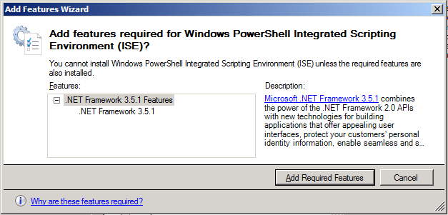

* 1. Now that you have selected these two features for installation, click the **Next** button on the **Add Features Wizard dialog** to continue with the install. The next screen you will ask you to Confirm Installation Selections. Click the **Install** button.

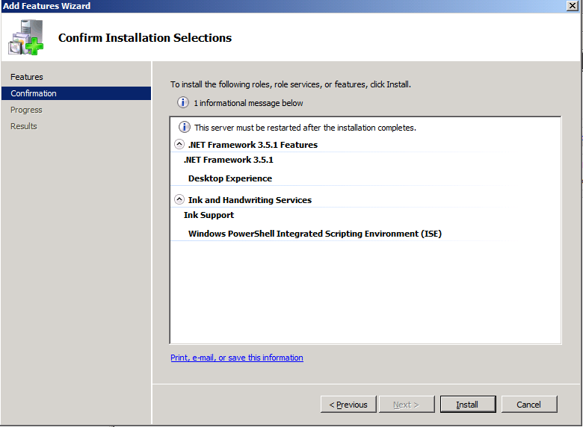

* 1. When you see the **Installation Results** screen, the Add Features Wizard informs you a computer restart is required. Click **Close** button to dismiss this dialog.

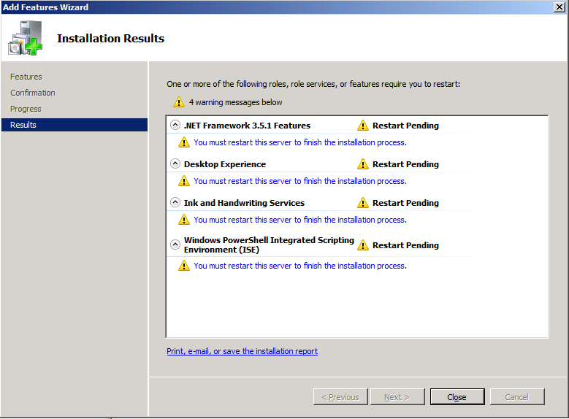

* 1. The final dialog of the Add Features Wizard prompts you to restart the VM. Click **Yes** to begin the rebooting process.

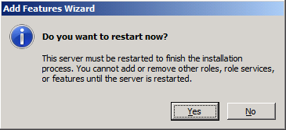

* 1. After the VM has restarted, login again as **Administrator** with a password of **Pass@word1**. Once you login, the feature installation process for Desktop Experience will automatically continue and complete.

1. Configure the **DisableLoopbackCheck** registry setting (Microsoft KB #896861).
   1. Launch the Windows Registry Editor. To do this click **Start**, click **Run**, type **regedit**, and then click **OK**.

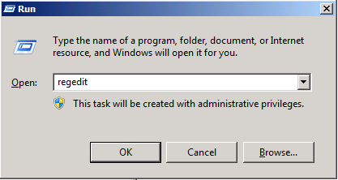

* 1. In Registry Editor, locate and then click the following registry key:

HKEY_LOCAL_MACHINE\SYSTEM\CurrentControlSet\Control\Lsa

* 1. Right-click Lsa, point to New, and then click **DWORD (32-bit) Value**.

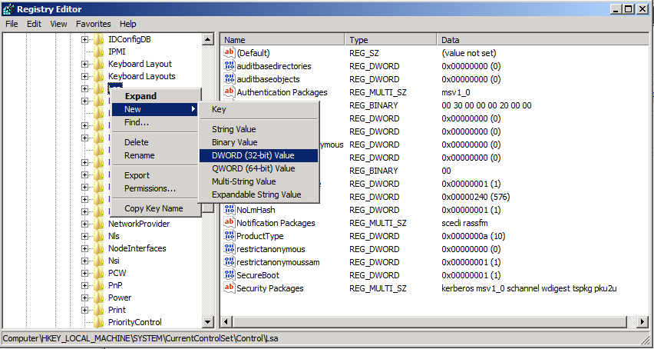

* 1. Type **DisableLoopbackCheck**, and then click Enter.
  2. Right-click **DisableLoopbackCheck**, and then click **Modify**.
  3. In the **Value data** textbox, type **1**, and then click **OK**.

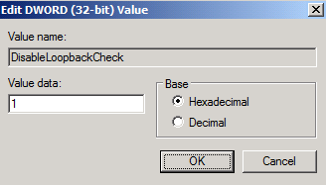

* 1. Quit Registry Editor.

1. Enabled Remote Desktop for your VM
   1. In the Server Manager, navigate to the top-level node to display the **Server Summary** page. Inside the **Computer Information** section, locate and click the link for **Configure Remote Desktop**. In the Remote tab of the **System Properties** dialog, select the last option for **Allow connections only from computers running** **Remote Desktop with Network Level Authentication**. Click **OK** to save changes and dismiss the **System Properties** dialog.

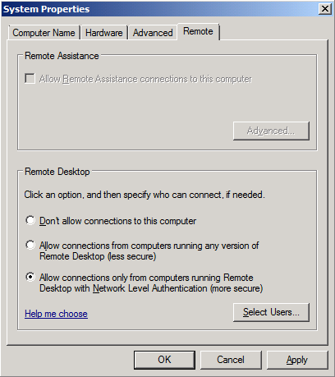

* 1. Now you should be able to connect through an RDP session. Many people prefer an RDP connection instead of the Hyper-V console. If you want to connect to this VM through an RPD connection, bring up a command prompt and run the **ipconfig** command to determine the IP address that has been assigned to your VM. Now you should be able to connect to your VM using RDP from another computer by using this IP address.

## Step 3: Configuring Active Directory

In this exercise, you will promote your VM to a domain controller and create a new domain named **wingtip.com**

1. Add and configure the role for Active Directory Domain Services
   1. Launch **Server Manager** and select the **Roles** node. You should see there are no roles have been installed
   2. Click the **Add Roles** link to start the Add Roles Wizard.
   3. On the Before you begin page, click **Next**
   4. On the **Server Roles** page, Select **Active Directory Domain Services**. If will are prompted with a dialog which asks to install **Microsoft .NET Framework 3.5.1**, click the **Add Required Features** button to dismiss this dialog. Click **Next** to advance the Add Roles Wizard.

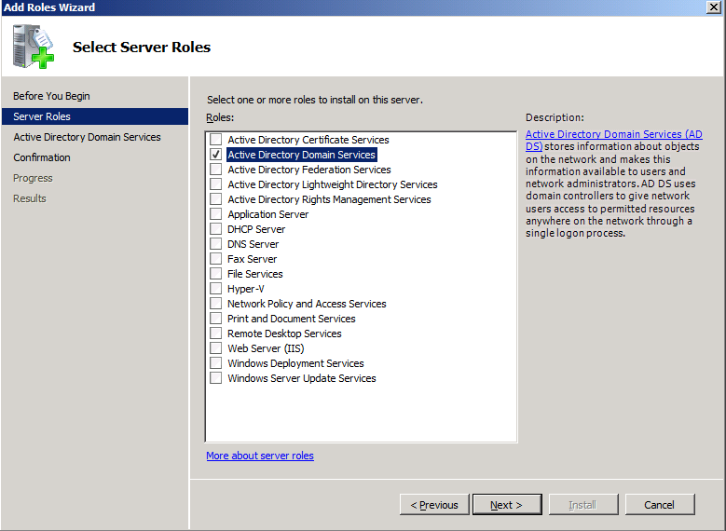

* 1. On the next page of the wizard, click **Next** which will bring you to the **Confirm Installation Selections** page. Click **Install**.

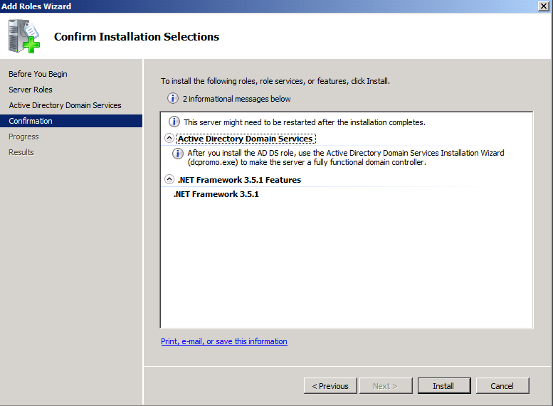

* 1. After Active Directory Domain Services has been installed, you will see the **Installation Results** page in the Add Roles Wizard as shown below. Click on the link with the big long caption of **Close this wizard and launch the Active Directory Domain Services Installation Wizard (dcpromo.exe)**.

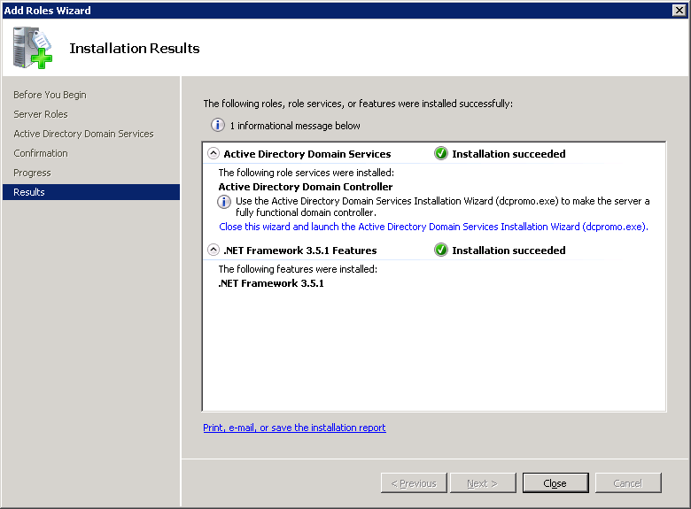

* 1. On the first page of the **Active Directory Domain Services Installation Wizard**, click the **Use advanced Mode installation** check box and click Next.

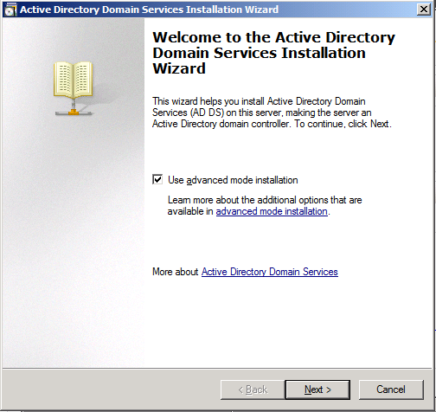

* 1. When you see the **Operating System Compatibility** page, click **Next**.
  2. The next page asks you to **Choose a Deployment Configuration**, select the option to **Create a new domain in a new forest** and click **Next**.
  3. The next page asks you to **Name the Forrest Root Domain**. Enter **wingtip.com** into the textbox for the root domain and click **Next**.

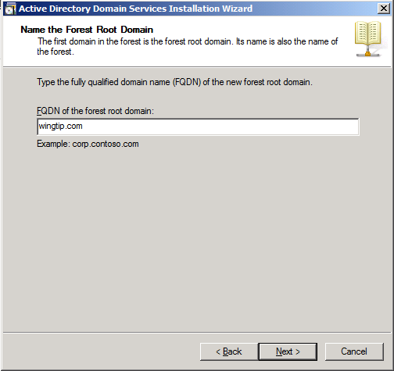

* 1. The next page asks you to assign the
  2. . The wizard should provide a default value of **WINGTIP**. Accept this default value and click **Next**.
  3. The next page asks you to **Set Forest Functional Level**. Using the dropdown list, change the setting to **Windows Server 2008 R2** and click **Next**.

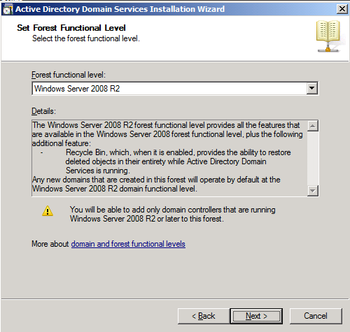

* 1. The next page asks you to set **Additional Domain Controller Options**. You should be able to accept the default options as shown below. Click **Next**.

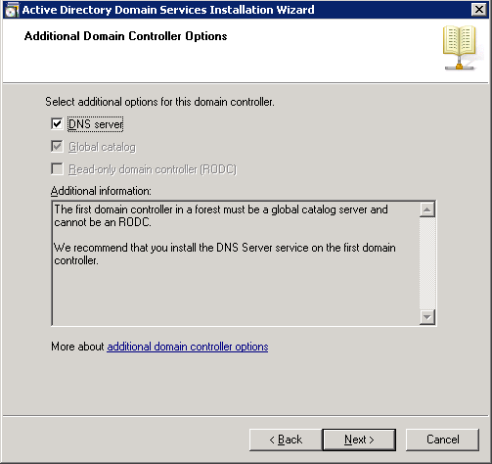

* 1. You might be prompted with the dialog shown below providing a warning that **This computer has dynamically assigned IP address(es)**. This is not a problem when you are running your development environment on a domain controller. Click **Yes** to dismiss the dialog.

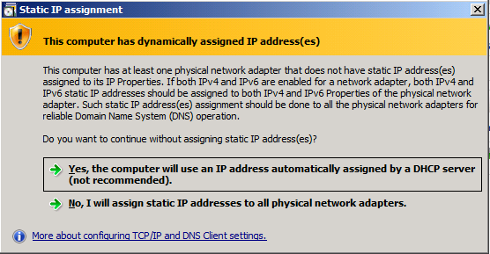

* 1. At this point the wizard will prompt you with a dialog information you a delegation for the DNS Server cannot be created because it cannot find the authoritative parent zone. This is not a problem because the wizard will automatically configure the DNS of the VM to point to itself. Click on the **Yes** button to dismiss this dialog.

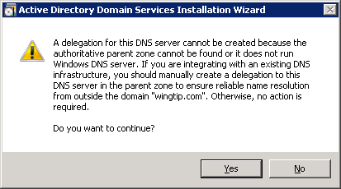

* 1. The next page asks you to set values for **Location for Database Log Files and SYSVOL**. Accept all the default values by clicking **Next**.

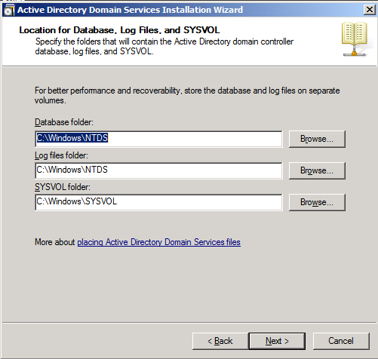

* 1. The next page asks you to provide and confirm a password for **Directory Services Restore Mode Administrator Password**. Add a password of **Pass@word1** and click **Next**.

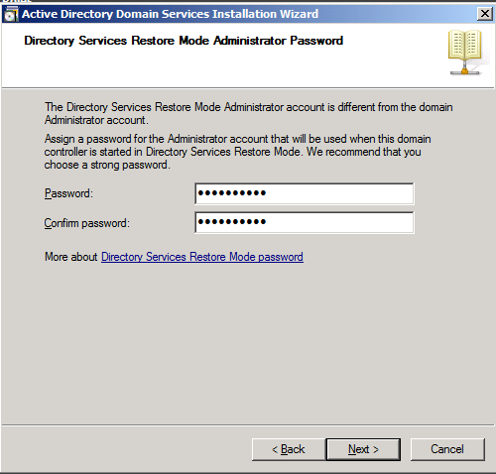

* 1. The next page is the **Summary** page which should show the values below. Click **Next** to start the process of configuring the new Active Directory domain.

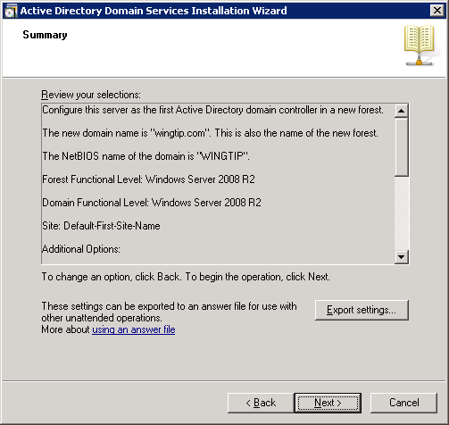

* 1. The wizard will display the dialog below to show you the progress of the configuration process. You will be required to reboot when the configuration has been completed. Check the option for **Reboot on completion** and then wait for the configuration to complete and the machine to reboot.

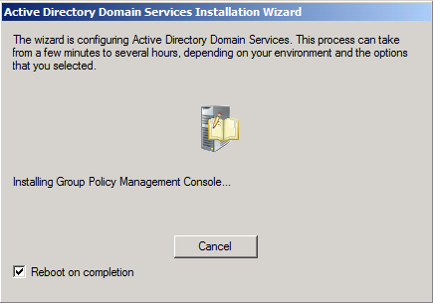

* 1. After the VM reboots, you should logon using the domain account **WINGTIP\Administrator**. The password should still be **Pass@word1**.

## Step 4: Configuring Windows Update

In this exercise you will run Windows Update one time and configure it to not run any more.

1. Select **Start > All Programs > Windows Update**.
2. First, disable Windows Update from running automatically:
   1. Click the link **Change Settings**.
   2. Under the **Important Updates** list, select **Never check for updates (not recommended)**. This isn’t what you would do in a production environment, but for a development machine it is ok.

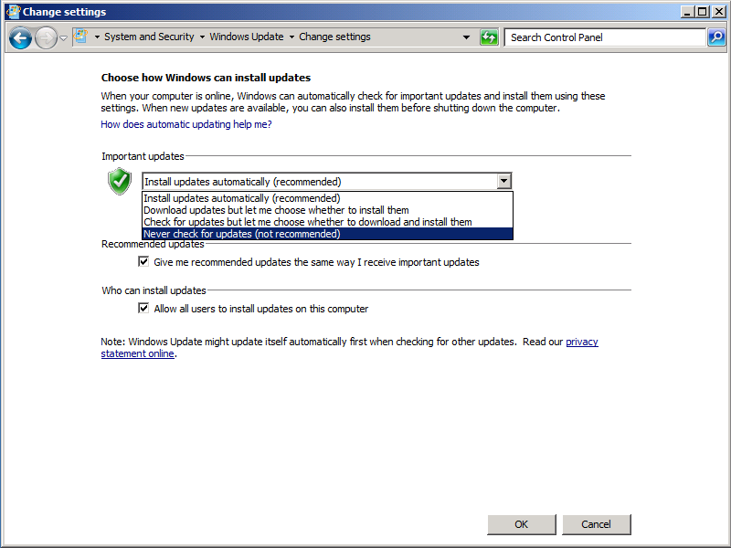

* 1. Now update the server. First select the **Check for Updates** link.
  2. Windows Update will the report how many updates are available. Click the **Install Updates** button. If prompted, select **I accept the license terms** for any updates that require it.
  3. When Windows Update completes, it’s a good idea to go ahead and reboot. Once the server has rebooted, login again.

## Step 5: Install SQL Server 2008 Enterprise

In this exercise you will install the Enterprise version of SQL Server 2008.

1. In this step, you will download the free trial version of SQL Server 2008 from the Microsoft download site using the following URL. Note that this free trial version is set to expire in 180 days after installation. If you have a registered version of SQL Server and a product key, you can install that instead of the free trial version in order to having the software expire in 180 days.
   1. Download the installation software to the hard drive of your host machine from this URL:

<http://www.microsoft.com/downloads/details.aspx?familyid=265f08bc-1874-4c81-83d8-0d48dbce6297>

* 1. After downloading, extract the ISO file named **SQLFULL_ENU.iso**.
  2. Inside the Hyper-V Manager, go to the settings for **WingtipServer** VM and mount **SQLFULL_ENU.iso** as to VM

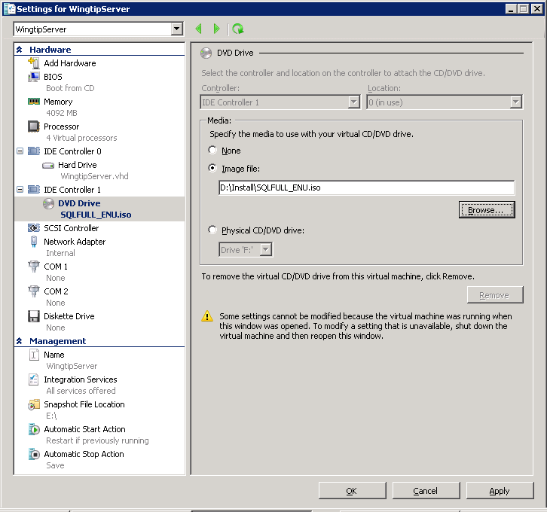

1. Logon to the VM and begin the installation of SQL Server 2008.
   1. Logon to the VM as **Wingtip\Administrator** with password of **Pass@word1**.
   2. Open the Widows Explorer navigate to the DVD drive.
   3. Double click on setup.exe to begin the installation process.
   4. A dialog warns you that you must install Service Pack 1 after installing SQL Server 2008. Accept the following dialog by selecting **Don’t show this message again** and clicking the **Run Program** button.

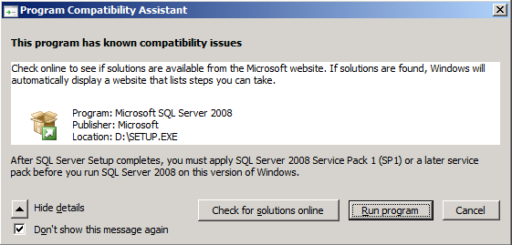

* 1. The setup process should now show the following window. Click the **Installation** link on the left-hand side of the window and then click the link which reads **New SQL Server stand-alone installation or** **add features to an existing installation**.

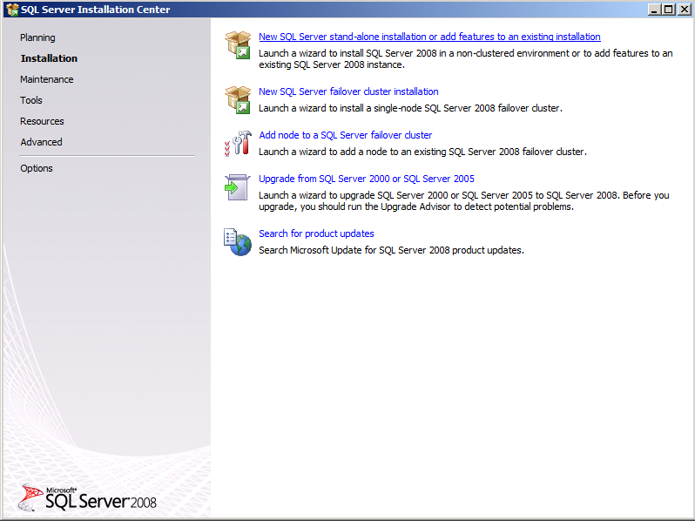

* 1. There are several windows at the beginning of the installation process that you should click **Next** to advance the installation process. At the **Product Key** page, select the **Enterprise Evaluation** and click **Next** to continue.

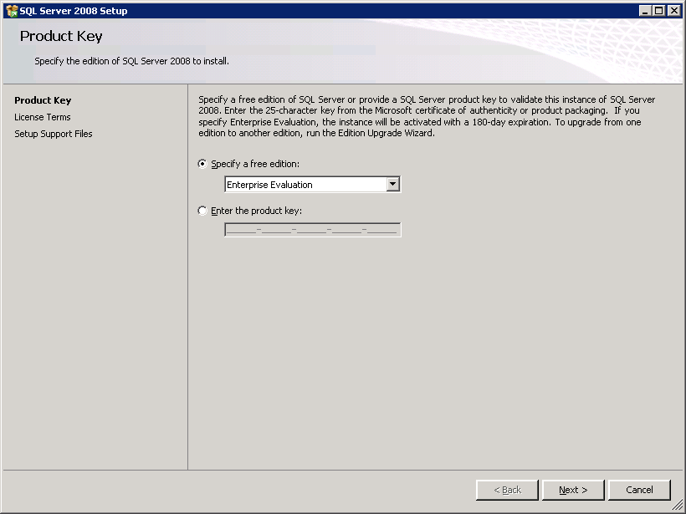

* 1. The next page is the **Setup Support Files** page. Click **Install** to continue.

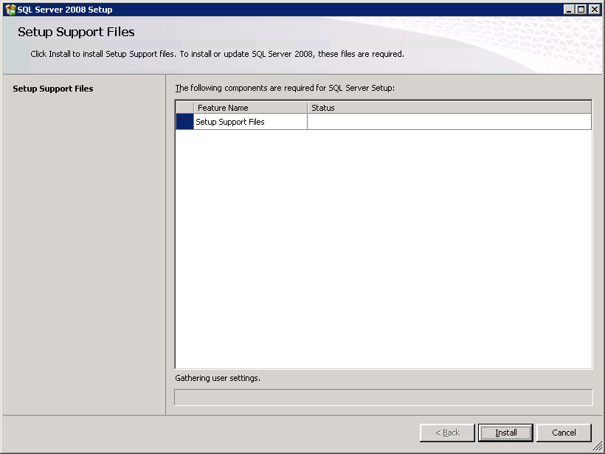

* 1. When you get to the **Setup Support Roles** page of the setup wizard, the installation process runs tests to make sure your VM meets the requirements. Your VM should pass all tests and the only warning you should receive is that you are installing SQL Server 2008 on a domain controller.

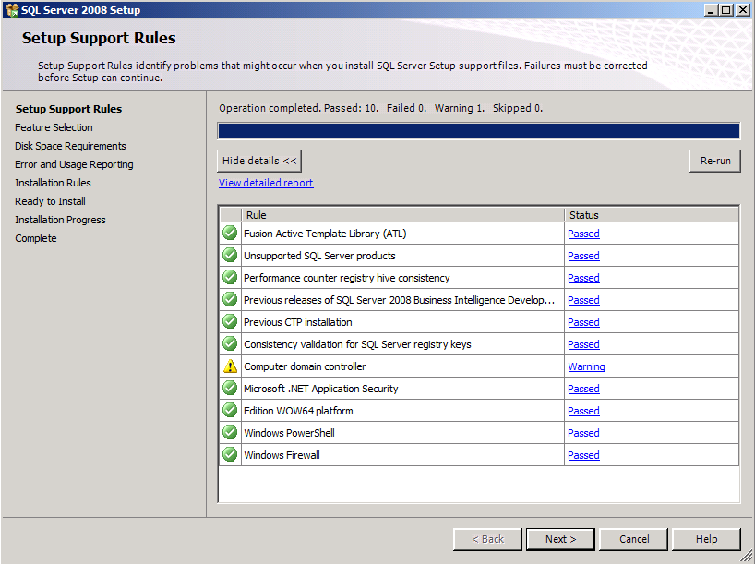

* 1. When you get to the **Feature Selection** page, select the features as shown in the screenshot below. Click **Next** to continue.

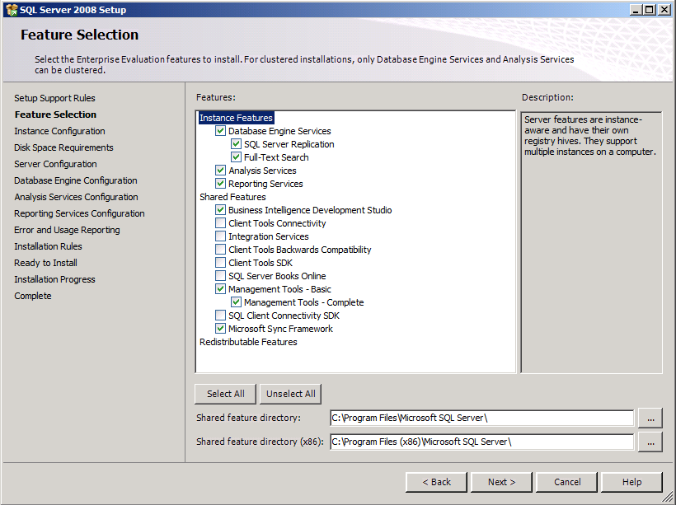

* 1. There is nothing to change on the **Instance Configuration** page. Click **Next** to continue.

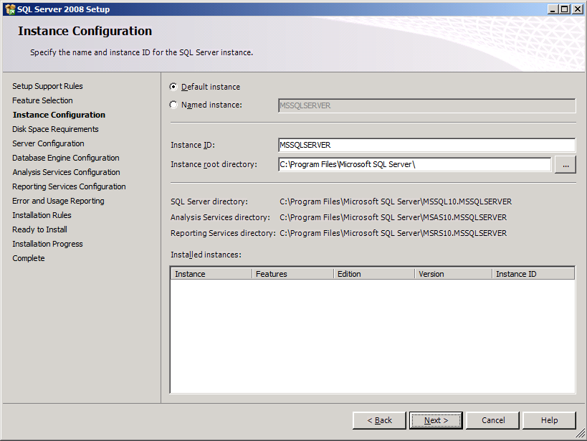

* 1. The next page is the **Server Configuration** page. Click the button with the caption of **Use the same account for all SQL Server instances**. When the dialog appears to select a user account, select the System account (**NT AUTHORITY\SYSTEM**) and click **OK**.

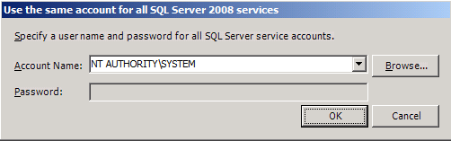

* 1. After you have completed the previous step, the **Server Configuration** page should appear like the one shown below. Click **Next** to continue.

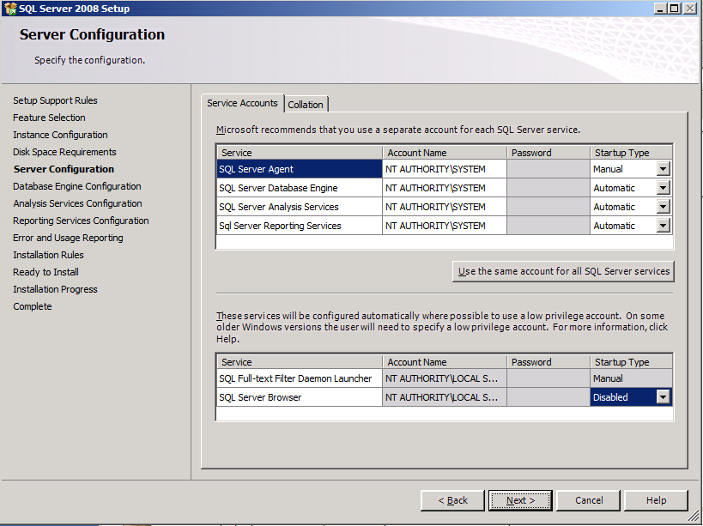

* 1. The next page is the **Database Engine Configuration** page. Specify **WINGTIP\Administrator** as a SQL Server administrator by clicking the **Add Current User** button at the bottom of the page. After the page looks like the one below, click on the **FILESTREAM** tab so that you can make changes there.

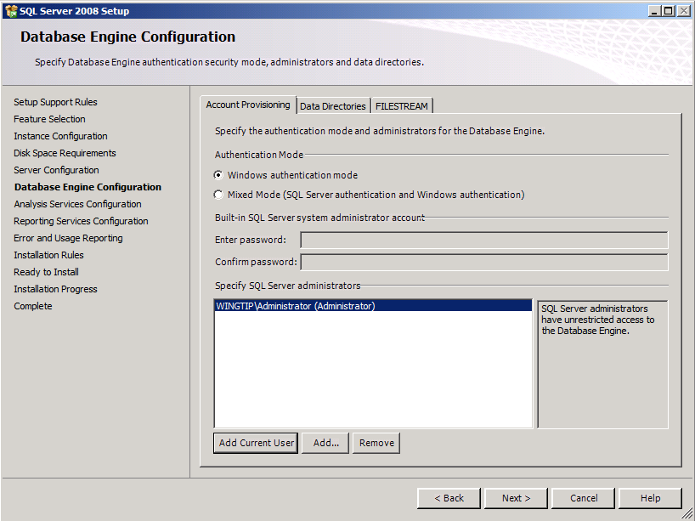

* 1. On the **FILESTREAM** tab of the **Database Engine Configuration** page, select the options for **Enable FILESTREAM for Transact-SQL access** and **Enable FILESTREAM for file I/O streaming access**. Click **Next** to continue.

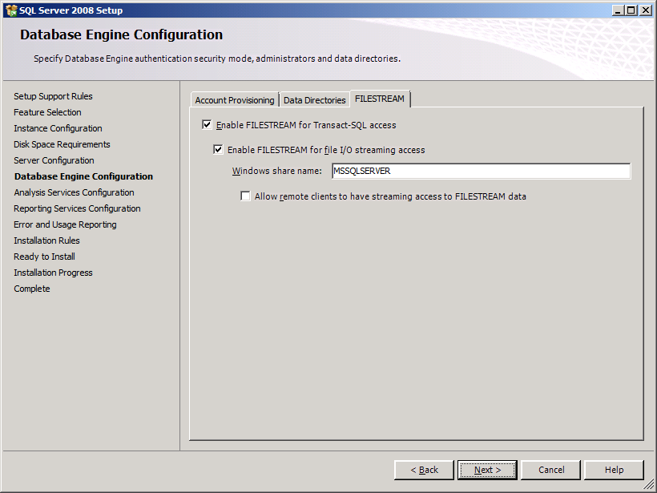

* 1. On the **Analysis Services Configuration** page, specify **WINGTIP\Administrator** as an Analysis Services administrator by clicking the **Add Current User** button at the bottom of the page. Click **Next** to continue.

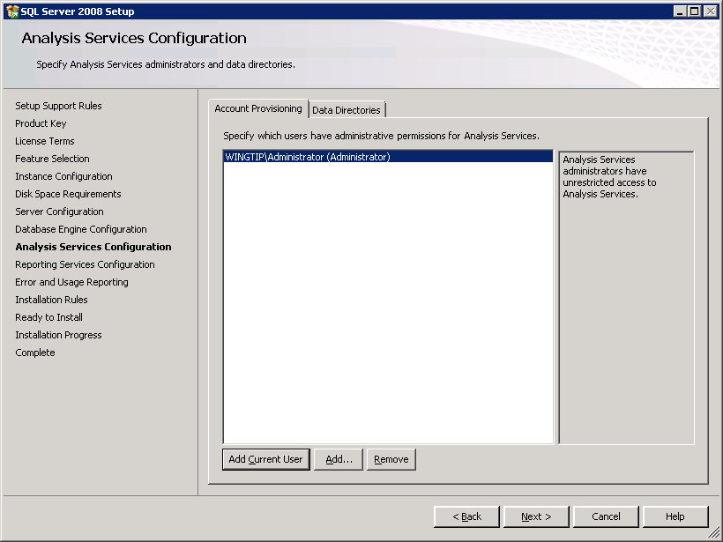

* 1. On the **Reporting Service Configuration** page, select the last option to **Install, but do not configure report server**. Click **Next** to continue.

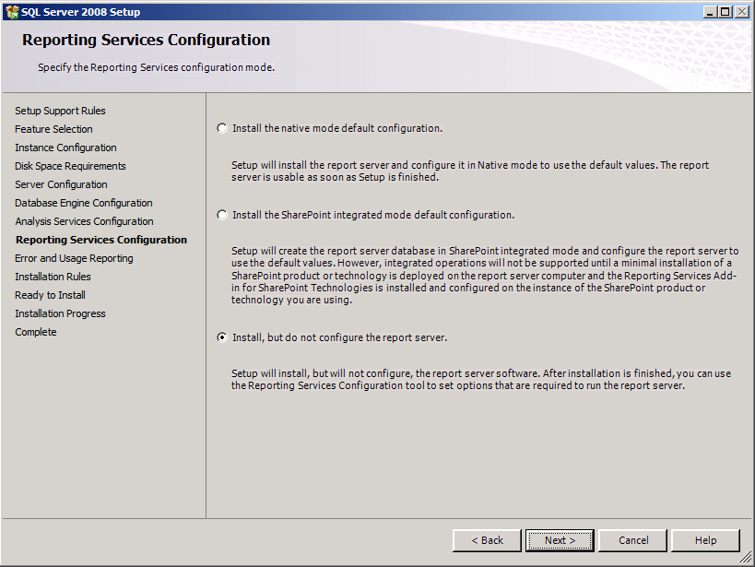

* 1. At the **Installation Rules** page, verify that your VM passes all tests. Click **Next** to continue.

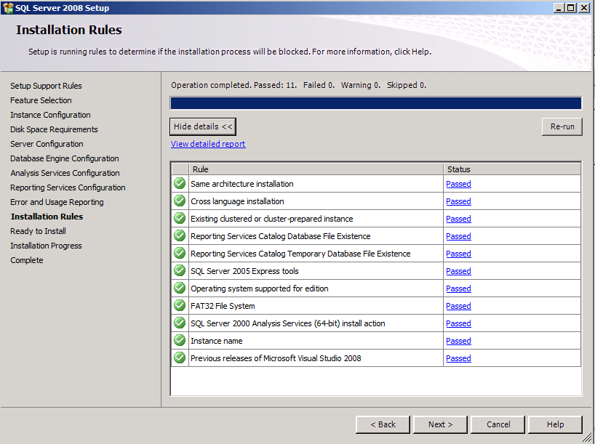

* 1. No changes are required on the **Error and Usage Reporting** page. Click **Next** to continue.
  2. No changes are required on the **Installation Rules** page. Click **Next** to continue.
  3. No changes are required on the **Error and Usage Reporting** page. Click **Next** to continue.
  4. On the **Ready to Install** page, click **Install** to begin the installation. The installation will take somewhere between 5 and 20 minutes depending on your hardware performance.
  5. When the installation is finished the **Installation Progress** page will display a **Setup progress complete** message. Click **Next** to continue.

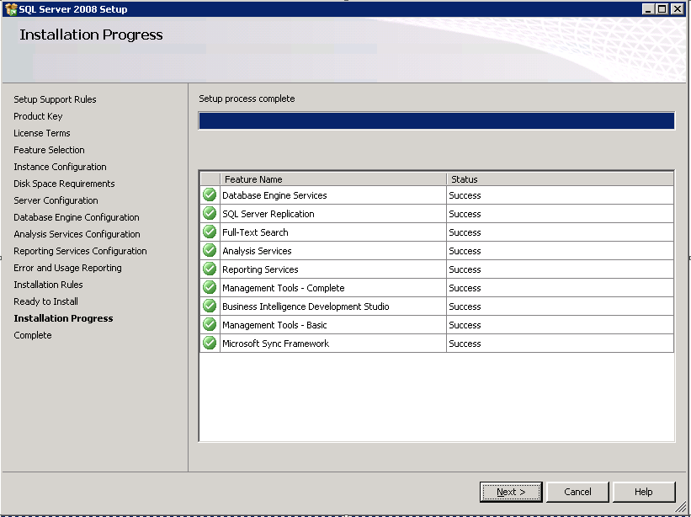

* 1. When you get to the **Complete** page you are finished with the installation. Click the **Close** button.

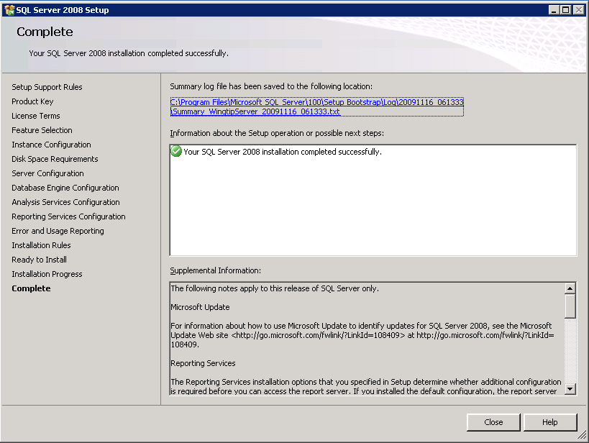

1. Install SQL Server 2008 SP1
   1. Go to the download page at the following URL

http://www.microsoft.com/downloads/details.aspx?familyid=66AB3DBB-BF3E-4F46-9559-CCC6A4F9DC19&displaylang=en

* 1. Download the 64-bit version which is **SQLServer2008SP1-KB968369-x64-ENU.exe**.
  2. Double click this EXE begin installation. Take all default options to install SP1.

1. Install SQL Server 2008 SP1 CU2
   1. Go to the download page at the following URL.

http://support.microsoft.com/kb/970315

* 1. Click the **View and request hotfix downloads** link at the top of the page. Follow instructions to obtain and install this hotfix on your VM.

1. Install Adventure Works Databases
   1. Go to the download page on CodePlex at the following URL.

http://msftdbprodsamples.codeplex.com/Release/ProjectReleases.aspx?ReleaseId=34032

* 1. Download the x64 version **SQL2008.AdventureWorks_All_Databases.x64.msi**.
  2. Install this MSI file on your VM to install the Adventure Works database.

1. Build Adventure Works Cube using SQL Server Business Intelligence Development Studio.
   1. Launch SQL Server BI Development Studio by using the shortcut in the Windows start menu: **Start > All Programs > Microsoft SQL Server 2008 > SQL Server Business Intelligence Development Studio**.



* 1. From within Business Intelligence Development Studio, you the **File** > **Open Project** menu command to open the project at the following location.

C:\Program Files\Microsoft SQL Server\100\Tools\Samples\AdventureWorks 2008 Analysis Services Project\enterprise\Adventure Works.sln

* 1. With the project open, right click on **Adventure Works DW 2008** project node and execute the **Deploy** command. The deployment process will take a minute or two to build out the Adventure Works data warehouse cube. You will receive a deployment success message after the deployment process completes.

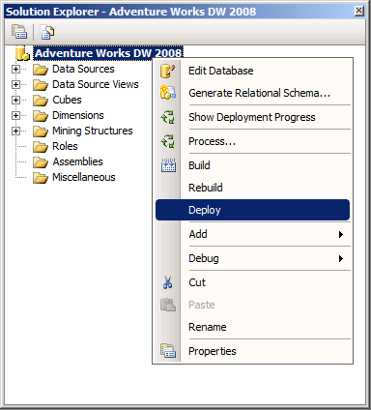

## Step 6: Install and Configure SharePoint Server 2010 Beta 2

Now it is time to install SharePoint Server 2010 Beta 2. You will begin by installing a few prerequisites and then you will install SharePoint Server 2010 and configure a local farm for development purposes.

1. Install Windows Server 2008 R2 Hot fix for WCF (64-bit version)
   1. Go to the following URL to see the download page for the hot fix installation file.

<https://connect.microsoft.com/VisualStudio/Downloads/DownloadDetails.aspx?DownloadID=23806&wa=wsignin1.0>

* 1. Download the file named **Windows6.1-KB976462-x64.msu** to the file system of the VM.
  2. Right click on file and choose **Install**.

1. Install ADO.NET Data Services version 1.5 CTP2
   1. Go to the following URL to see the download page.

[http://www.microsoft.com/downloads/details.aspx?FamilyID=a71060eb-454e-4475-81a6-e9552b1034fc](http://www.microsoft.com/downloads/details.aspx?FamilyID=a71060eb-454e-4475-81a6-e9552b1034fc&displaylang=en)

* 1. Run the install **ADONETDataServices_v15_CTP2.exe**.
  2. During the install of ADO.NET Services you will encounter an error which brings up the set warning dialog shown below. This error will not cause any problems so you can click **OK**.

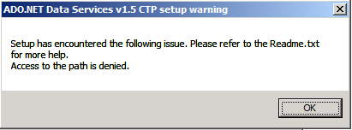

In the next step you will create a new user account named **SP_WorkerProcess** that will serve as the identity for the worker pool processes used by SharePoint Server. You will create this account as a domain account in the WINGTIP directory as to simulate a production environment. Note, however, that this setup document reduces complexity by using a single user account to configure all SharePoint Server worker processes while a true production environment will likely employ multiple user accounts so that various Web Applications like Central Administration could have a unique identity.

1. Create new user account in Active Directory for SharePoint Worker Process identity
   1. Launch the Active Directory Users and Computers from the Windows Start menu  
      **Start > Administrative Tools > Active Directory Users and Computers**.
   2. Navigate to the **Users** node. Right click on this node and execute the **New > User** menu command as shown in the screenshot below.

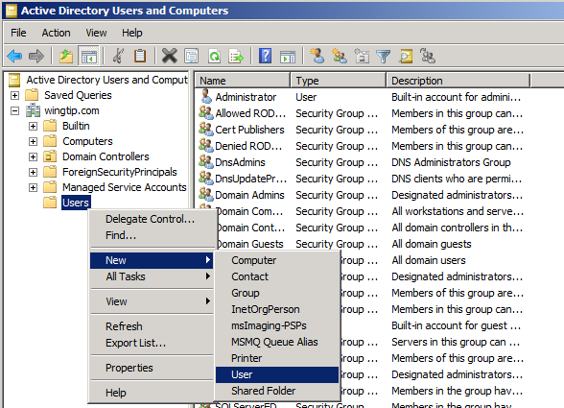

* 1. Create new account named **SP_WorkerProcess** by filling out the dialog as shown.

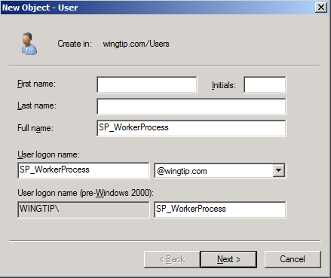

* 1. Give the new user account a password of **Pass@word1**.

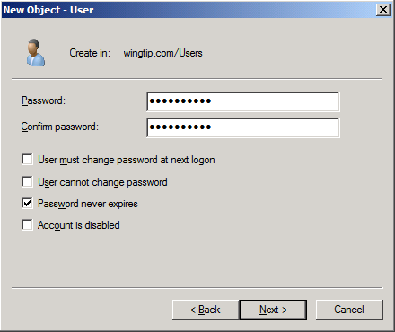

* 1. When you are done you should be able to verify you can see the new **SP_WorkerProcess** account inside the **Users** node.

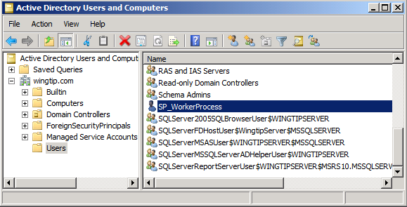

1. Download the SharePoint Server 2010 Beta 2 installation files and obtain your product key.
   1. Inside the browser, go to the following link:

[http://technet.microsoft.com/en-us/evalcenter/ee388573.aspx](http://intranet.wingtip.com)

* 1. Register to download **SharePoint Server 2010 Beta (Enterprise Cal Features)**.
  2. Click the **Get Started Now** button
  3. Next, you will be prompted to login with your Microsoft Live ID. If you do not have a Microsoft Live ID, you must register to get one so that you can complete this step.
  4. You will also be required to fill out some profile information about yourself and your company. Fill in the required information.
  5. Make sure you obtain a product key for **SharePoint Server 2010**.
  6. Download the file named **OfficeServer.exe** to hard drive of host computer.
  7. Extract the setup files into a location where they are accessible to your VM. For example, if you downloaded **OfficeServer.exe** to the **c:\Install** directory on the local hard drive of your host computer, you can extract the SharePoint Server 2010 setup files into a child directory named **c:\Install\SharePoint2010** by running the following command from the command line.

c:\Install\OfficeServer.exe /extract:c:\Install\SharePoint2010

* 1. Configure the directory with the extracted SharePoint Server 2010 setup files as a network share so that you can access the files from within the VM.

1. Run the SharePoint 2010 Prerequisite Installer
   1. Inside the top-level directory of the SharePoint Server 2010 install files, locate and run **PrerequisiteInstaller.exe**.
   2. Click **Next** at the welcome screen to install the SharePoint Server prerequisites.

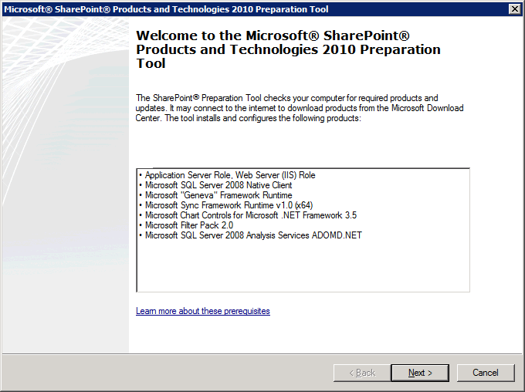

* 1. After running **PrerequisiteInstaller.exe**, reboot the VMs.

1. Install SharePoint Server 2010 Enterprise.
   1. Inside the top-level directory of the SharePoint Server install files, locate and run **setup.exe**.
   2. When prompted, enter you product key for SharePoint Server 2010.

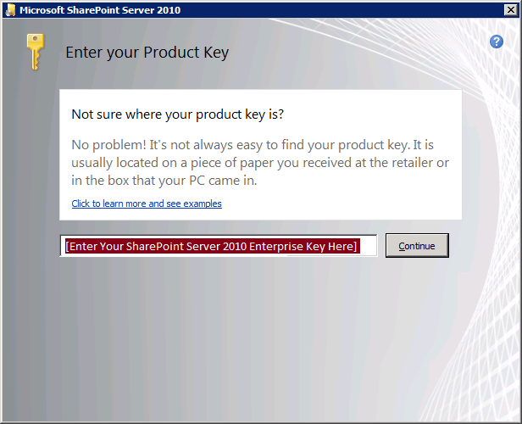

* 1. Accept terms of Agreement
  2. When asked to **Choose the installation you want**, select to install **Server Farm.**

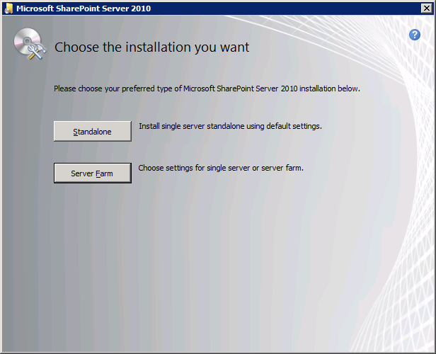

* 1. For **Server Type**, select **Complete** & then click the **Install Now** button.

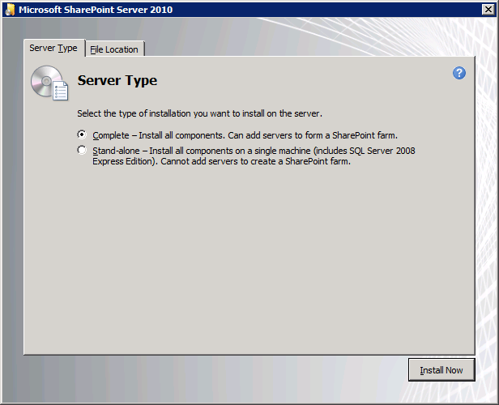

* 1. When installation is finished, you are prompted to **Run the SharePoint Products and Technologies Configuration Wizard now**. Click **Close** to begin this wizard.

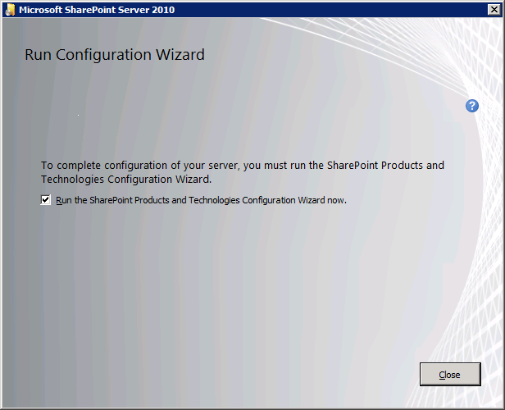

1. Create the **Configuration Database** and **Central Administration Web application** using the SharePoint Products and Technologies Configuration Wizard
   1. On the **Welcome to SharePoint Products** page, click **Next** to continue.

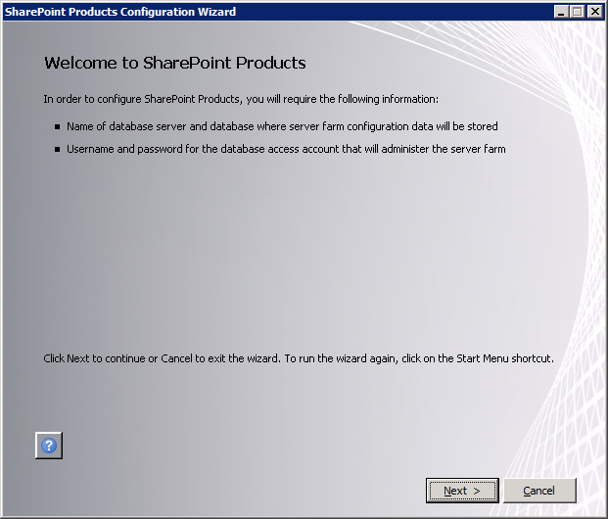

* 1. A dialog will ask you whether it is OK to stop IIS and a few other services. Click **Yes** on this dialog to continue with the configuration process.

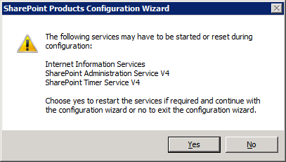

* 1. On the **Connect to a server farm** page, Select **Create a new server farm** and click **Next** to continue.

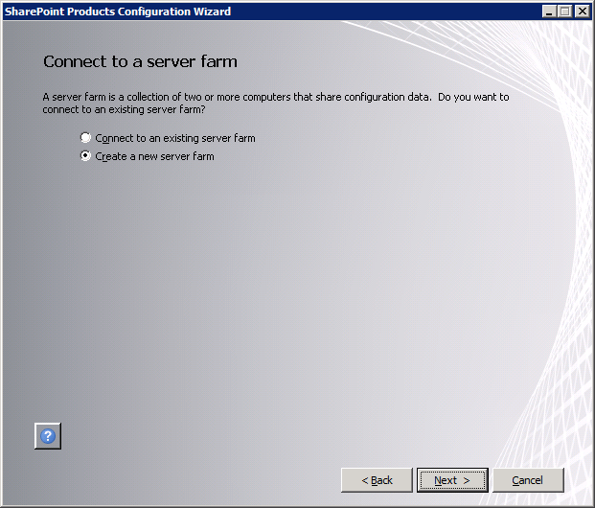

* 1. The next page is the **Specify Configuration Database Settings** page. Fill in these settings with these value.  
     Database server: **WingtipServer**Database name: **Wingtip_ConfigDB**Username: **Wingtip\SP_WorkerProcess**Password: **Pass@word1**

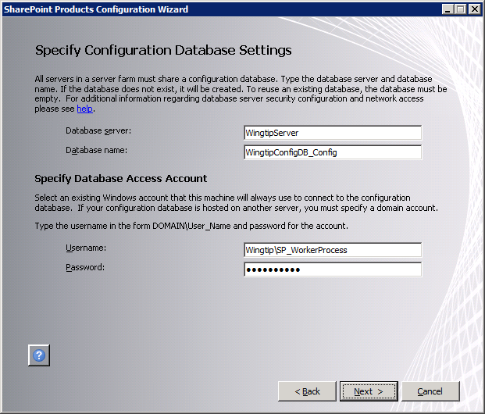

* 1. One you filled in the configuration database settings, click **Next** to continue.
  2. The next page is the **Farm Security Settings** page which asks you to add and confirm a passphrase. Add and confirm a passphrase value of **Pass@word1** and click **Next** to continue.

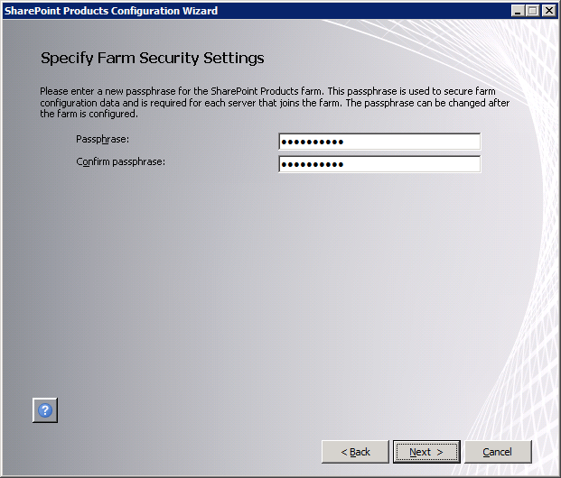

* 1. On the Configure SharePoint Central Administration Web Application page, select the option to **Specify port number** and add a port number value of **9999**. Leave the **Configure Security Settings** authentication provide settings at the default value of **NTLM**. Click **Next** to continue.

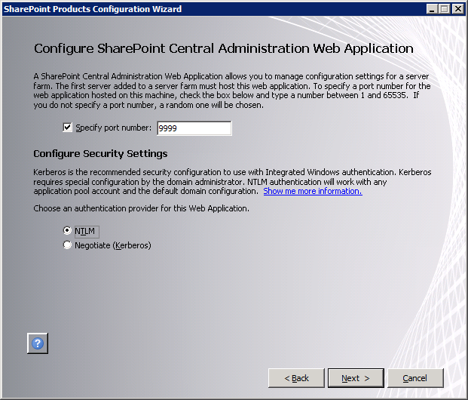

* 1. Review your configuration settings in the **Completing the SharePoint Products Configuration Wizard** page. Click **Next** to begin the configuration.

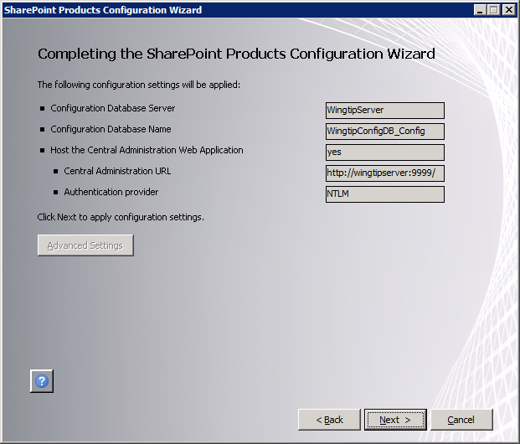

* 1. SharePoint will now begin configuring itself which should take 5-10 minutes depending on the performance of your hardware. When you are done, you will a page with the title of **Configuration Successful**.

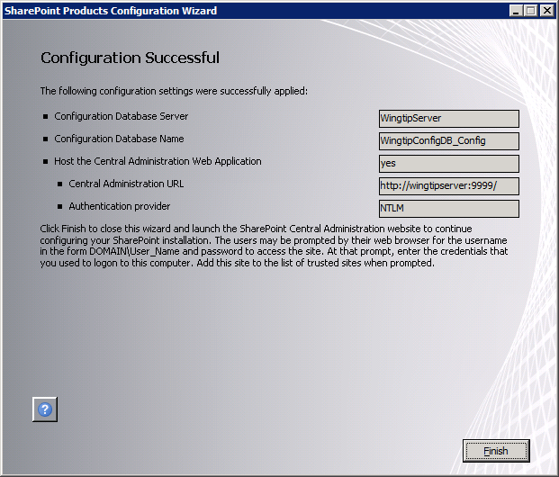

* 1. Click the **Finish** button and you will be directed to a page in Central Administration at the URL of <http://wingtipserver:9999/_admin/adminconfigintro.aspx>. This page starts the **Farm Configuration Wizard**.

1. Configure the farm’s service applications using the **Farm Configuration Wizard**.
   1. The first dialog of the **Farm Configuration Wizard** asks you whether you want to participate in the Customer Experience Improvement Program. Select the option **No, I don’t wish to participate** and click **OK** to continue.

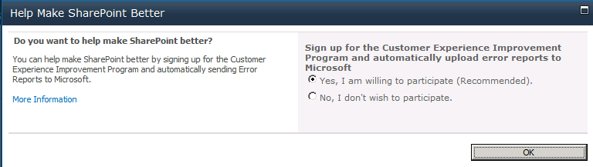

* 1. The next page of the wizard asks **How do you want to configure your SharePoint farm?** Select the option **Walk me through the settings using the wizard. I will select the services to use in this farm and the type of site to create**. Click **Next** to continue.

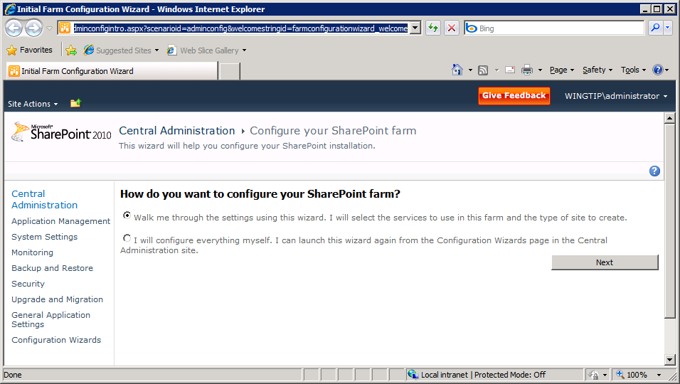

* 1. Next page of the **Farm Configuration Wizard** asks you to select a service account for running the farm’s service applications. Select the option to Use existing managed account and make sure the domain account **WINGTIP\SP_WorkerProcess** is selected. You do not need to change anything in the **Services** section because you can accept the default selections. Click **Next** to continue.

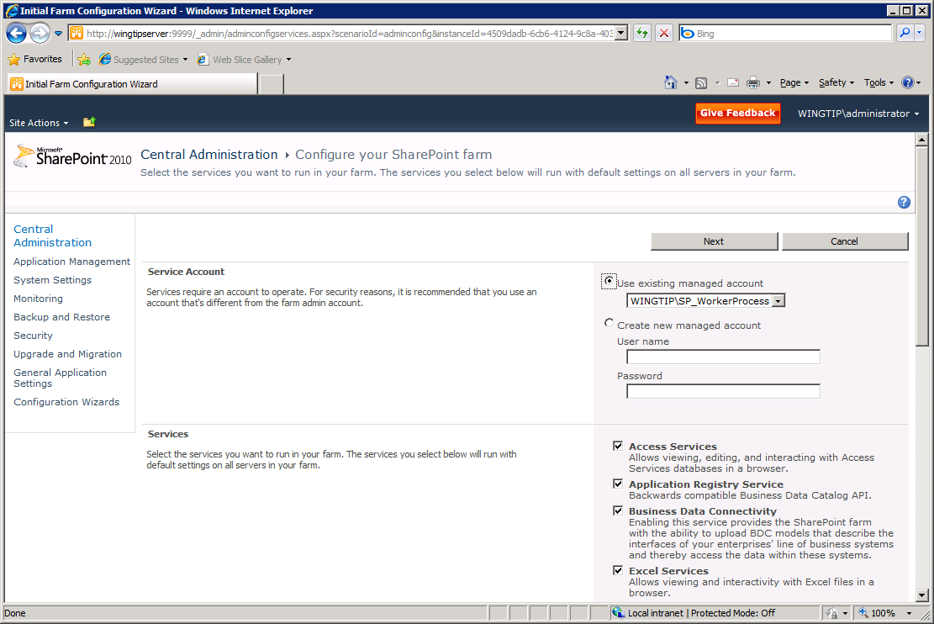

* 1. In addition to provisioning the farm’s service application, the Farm Configuration Wizard also creates a new Web Application using the URL of the machine name (**http://WingtipServer**) and asks you if you want to create a new site collection at the root. Select the site template named **Team Site** and click **OK** to continue.

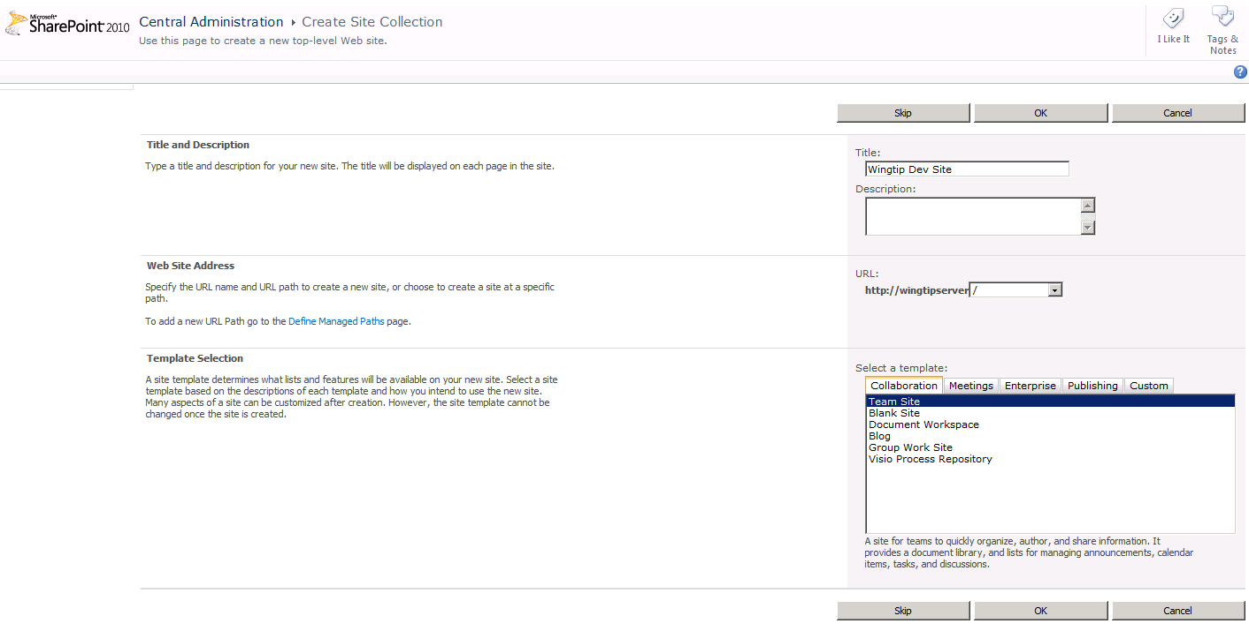

* 1. Now you are finished with the **Farm Configuration Wizard**. Click **Finish**.

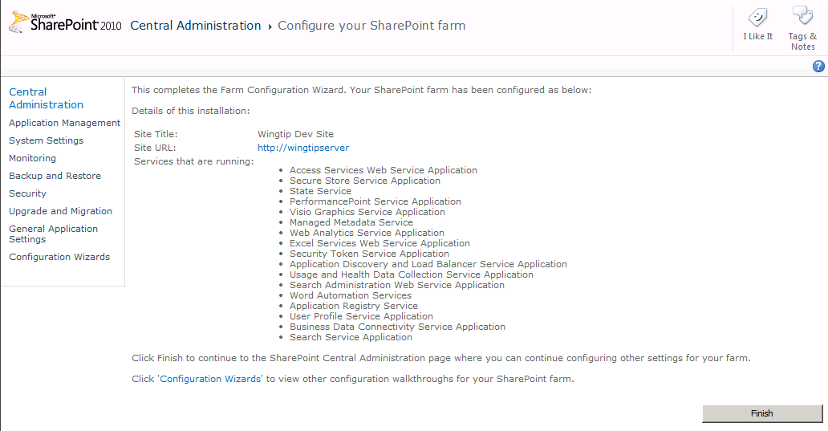

* 1. When the **Farm Configuration Wizard** completes, it will redirect you to the home page of the Central Administration application.

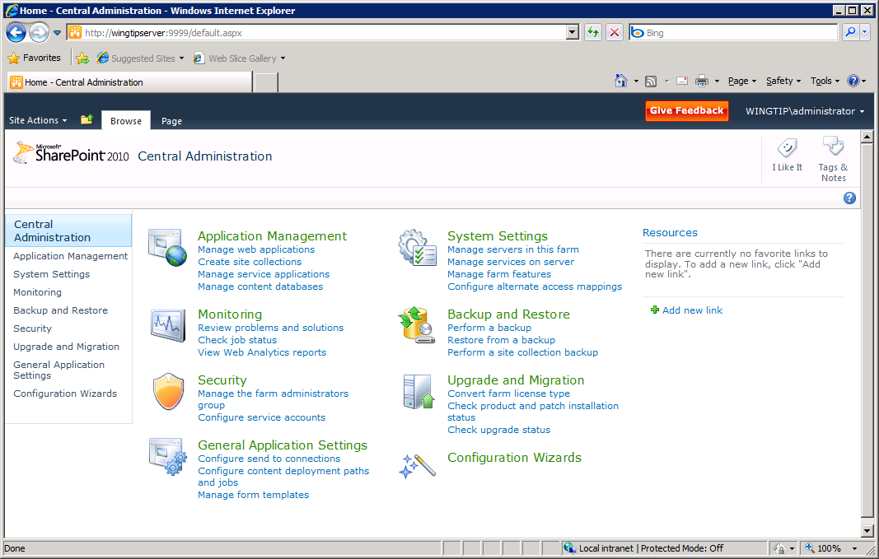

## Step 7: Creating a new Web Application at http://intranet.wingtip.com

Now you will create and configure a new Web Application at the URL of **http://intranet.wingtip.com**. You must begin by configuring DNS with Windows Server 2008 R2 and then you will use the Central Administration application to create and configure the new Web Application.

1. Configure DNS setting on the VM so <http://intranet.wingtip.com> points to local machine.
   1. Launch the **DNS Manager** from its shortcut in the Windows **Start** menu in the **Administrative Tools** group.

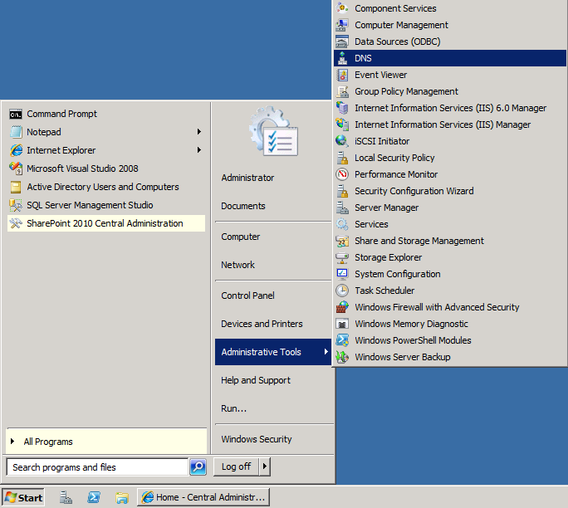

* 1. In the DNS Manager, expand the nodes and locate for the wingtip.com domain at the following path: **DNS > WINGTIPSERVER > Forward Lookup Zones > wingtip.com**. Right click on the wingtip.com nodeand click **New Alias (CNAME)**.

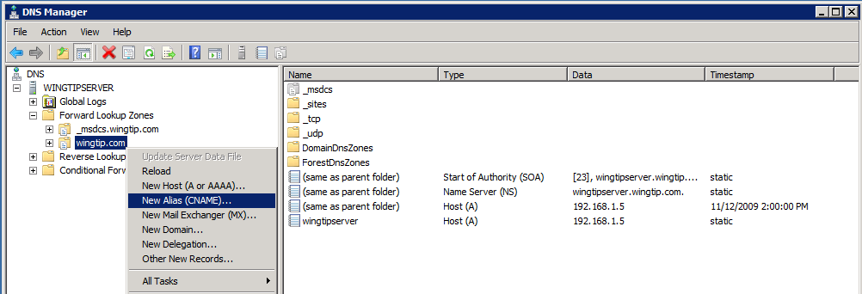

* 1. In the **New Resource Record** dialog, enter name of **intranet** as the **Alias Name** and then click the **Browse** button to create the **Fully Qualified domain name**.

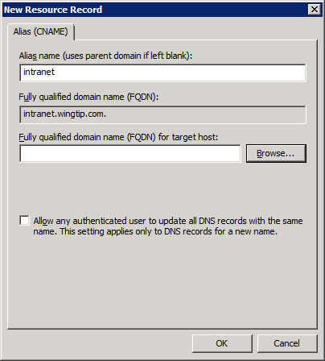

* 1. When the **Browse** dialog appears, drill down to the wingtip.com node by following the path of **WingtipServer > Forward Lookup Zones > wingtip.com**. Inside the node for wingtip.com, find and select the record for **wingtipserver** as shown below. Click **OK**.

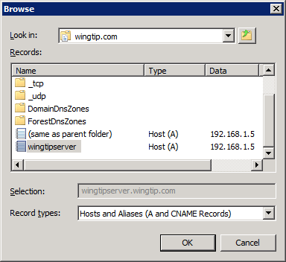

* 1. When you have completed this step, you should be able to verify that you created a new record for **intranet.wingtip.com** as shown in the following screenshot.

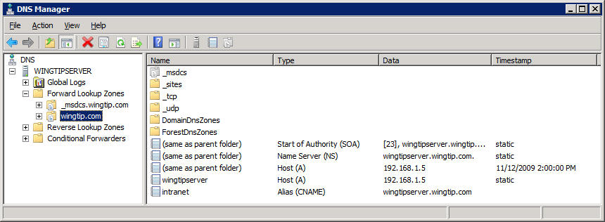

* 1. Verify the new DNS setting works properly by bringing up a Windows command prompt and running the DOS **ping** command on the address of <http://intranet.wingtip.com>.

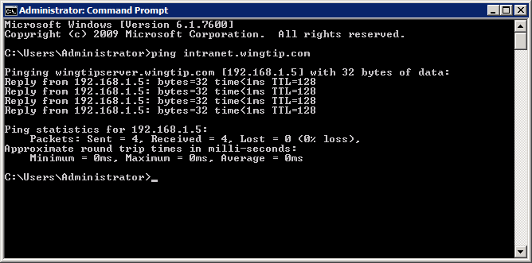

1. Create a new Web Application at the URL of **http://intranet.wingtip.com**.
   1. Navigate to the home page of the Central Administration application. If it is not already running, launch it from **Start > All Programs > Microsoft SharePoint 2010 Products > SharePoint 2010 Central Administration**.
   2. Inside the **Application Management** section, click on the link with the caption of **Manage web applications** to navigate to the **Web Application Management** page.
   3. Make sure the **Web Application** tab is selected. Click the **New** button on the very left-hand side of the Ribbon.

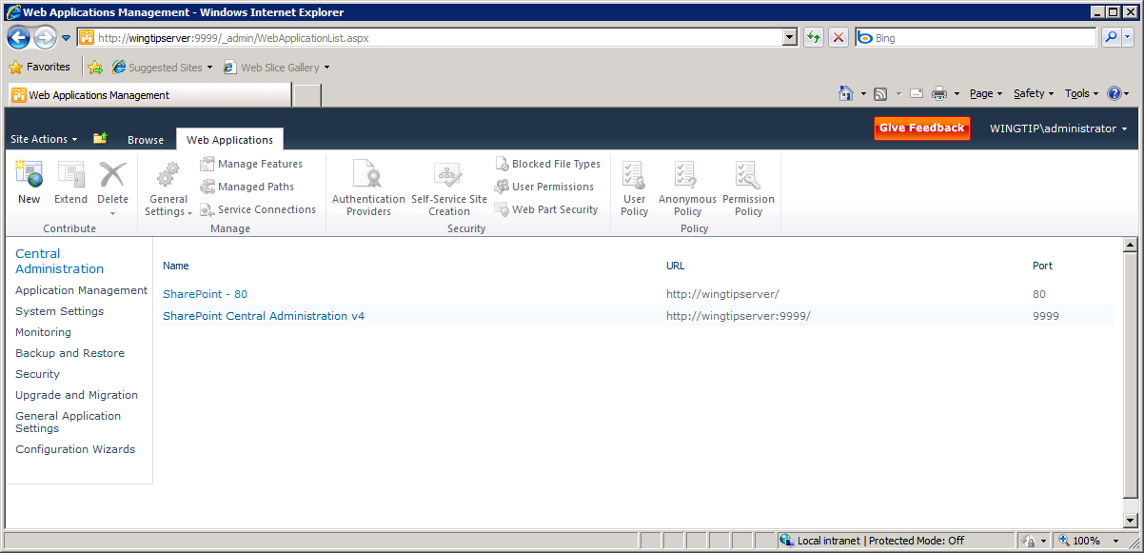

* 1. The **Create New Web Application** dialog appears. Note that this is a very tall page and you will have to scroll down to see and fill out all the information required to create a new Web application. There are no changes required in the Authentication section because you should leave the default setting of **Classic Mode Authentication**.

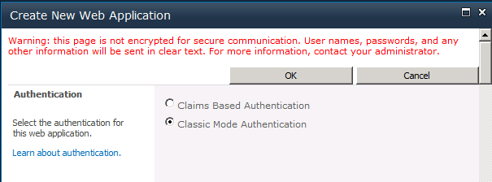

* 1. Scroll down to the **IIS Web Site** section. Select the option to **Create a new IIS web site** and enter a **Name** of **Wingtip Intranet**. Enter a **Port** of **80**. For the **Host Header** setting, add a value of **intranet.wingtip.com**. Add a **Path** value of **c:\inetpub\WingtipIntranet**. When you are done, you entries should look like the ones below.

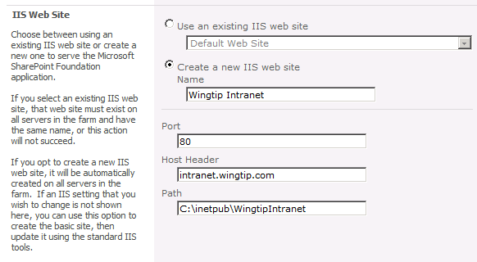

* 1. Scroll down to the Security Configuration section and fill it out so it looks like the following screenshot.

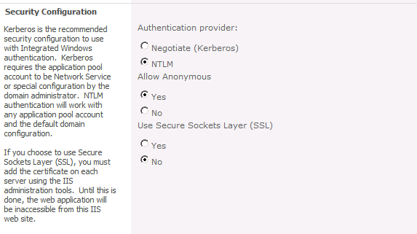

* 1. Scroll down to the Scroll down to the **IIS Web Site** section. section. Remove “80” from end of URL so its value is **http://intranet.wingtip.com**.

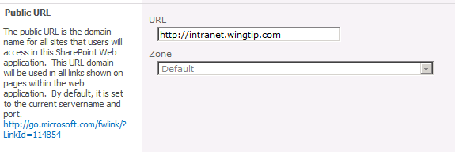

* 1. Scroll down to the Application Pool section. Select the option to **Create new application pool** and enter an **Application pool name** of **SharePoint Default App Pool**. Make sure you configure the identity for the new application pool with the **WINGTIP\SP_WorkerProcess** account as shown in the following screenshot.

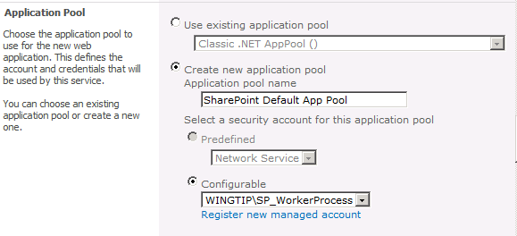

* 1. Scroll down to the **Database Name and Authentication** section. Make sure the Database Server setting has a value of **WingtipServer**. Next, give the content database a descriptive name of **WingtipIntranet_ContentDB**. Leave the authentication settings at the default value of **Windows authentication**.

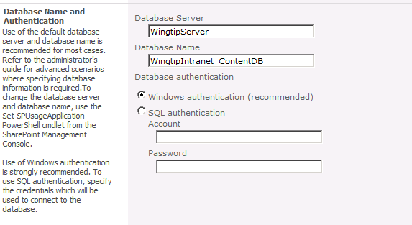

* 1. At this point, you have configured all the necessary information to create the new Web application at **http://intranet.wingtip.com**. You can leave all other settings with their default values. Scroll down to the bottom of the page disable the option for the **Customer Experience Improvement Program**. Click **OK** to provision the new Web Application.
  2. After SharePoint Server provisions the new Web application, it displays the following dialog. Click on the blue link with the caption of **Create Site Collection**.

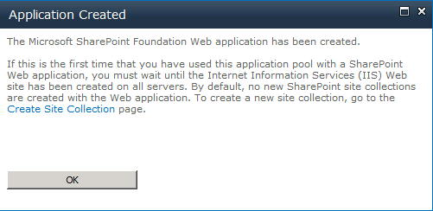

* 1. The next page provides input controls for you to enter information about the new site collection. Enter a **Title** of **Wingtip Intranet**. Leave the **URL** with its default setting so that the new site collection is created at the root of the Web application. Select **Team Site** as the site template for the top-level site. Configure the **Primary Site Collection Administrator** setting with the user account **WINGTIP\SP_WorkerProcess**. Click **OK** to begin the provisioning process.

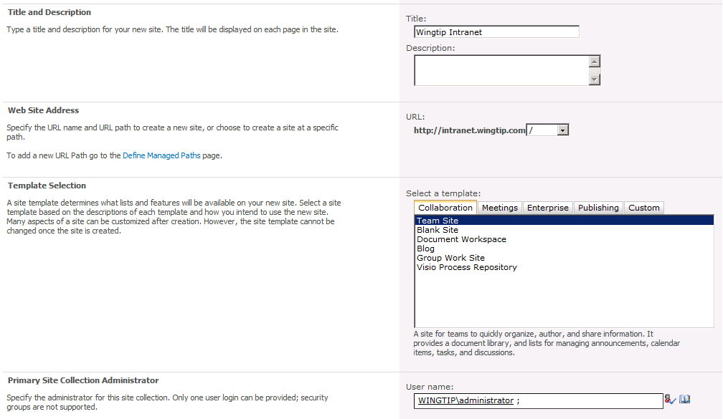

* 1. After the new site collection has been created, go to its top-level site by navigating to the URL of [http://intranet.wingtip.com](http://www.microsoft.com/downloads/details.aspx). You will be prompted for a loin and password. Enter **Wingtip\Administrator** and a password of **Pass@word1**. You should be able to see the home page of the site running inside the Web application you just created.

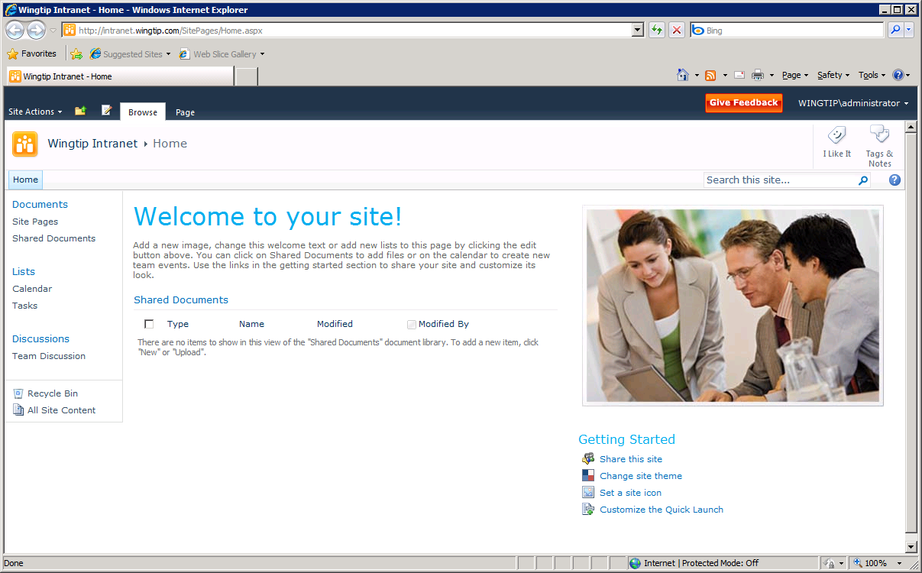

1. Configure Internet Explorer for automatic Windows authentication. The purpose of this step is to eliminate the need to enter a user name and password when you navigate to this site or any other site within the Web application at **http://intranet.wingtip.com**.
   1. Inside the Internet Explorer, drop down the **Tools** menu and select **Internet Options**.

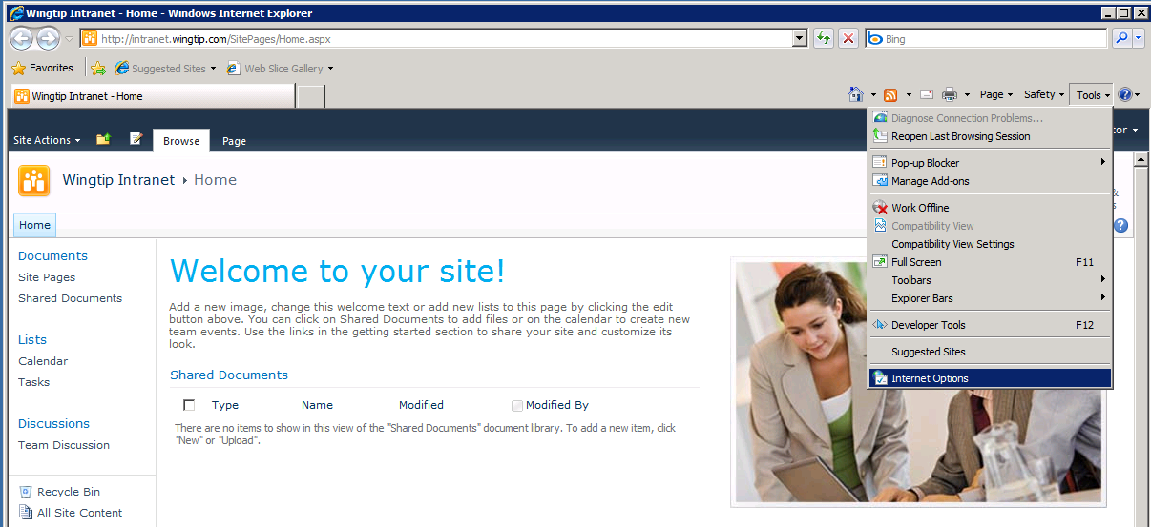

* 1. In the **General** tab of the **Internet Options** dialog, enter a **Home page** address of [**http://intranet.wingtip.com**](http://www.microsoft.com/downloads/details.aspx). Click the **Apply** button to save your setting.

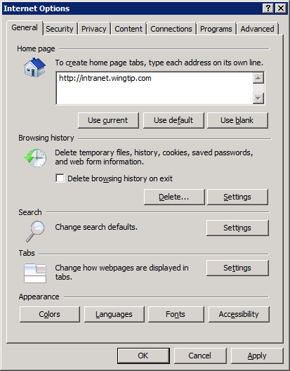

* 1. Navigate to the **Security** tab of the **Internet Options** dialog. Select the zone named **Local Intranet**. Click the **Sites** button to configure the **Local Intranet** zone.

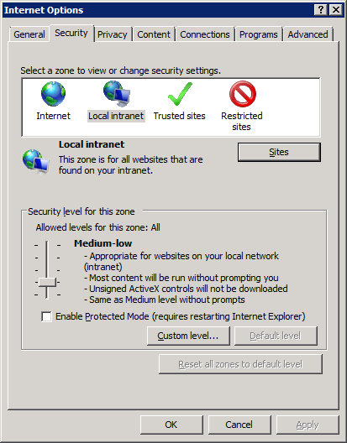

* 1. When you click the Site button in the previous step, the Internet Explorer will display the following dialog. Click on the **Advanced** button

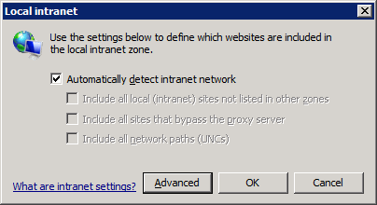

* 1. The next dialog allows you to add one or more URLs that will be added to the Local Intranet zone. Add the URL of http://intranet.wingtip.com.

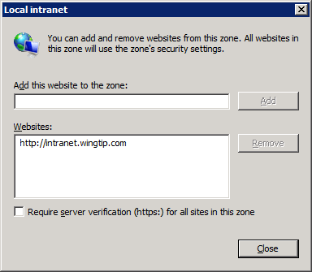

* 1. Click **Close** to dismiss the first dialog. Next click OK to dismiss the next dialog which should bring you back to the original Internet Options dialog. Click OK to save all your changes.
  2. Now close the Internet Explorer and then reopen it. You should be able to see the home page of the new Team Site you created at [http://intanet.wingtip.com](http://technet.microsoft.com/en-us/evalcenter/ee388573.aspx) without having to enter any login information.

1. Enable the user code service (for sandboxed solutions).
   1. The user code service used by sandboxed solutions is not started by default. However before starting it you need to address an issue. In SharePoint 2010 Beta 2 the user code service will not run when SharePoint is running on an Active Directory domain controller. This can be fixed by running a simple PowerShell script
   2. Open the PowerShell ISE by selecting **Start > All Programs > Accessories > Windows PowerShell > Windows PowerShell ISE**.
   3. Enter the following script and run it in the ISE:

$acl = Get-Acl HKLM:\System\CurrentControlSet\Control\ComputerName

$person = [System.Security.Principal.NTAccount]"Users"

$access = [System.Security.AccessControl.RegistryRights]::FullControl

$inheritance = [System.Security.AccessControl.InheritanceFlags]"ContainerInherit, ObjectInherit"

$propagation = [System.Security.AccessControl.PropagationFlags]::None

$type = [System.Security.AccessControl.AccessControlType]::Allow

$rule = New-Object System.Security.AccessControl.RegistryAccessRule($person, $access, $inheritance, $propagation, $type)

$acl.AddAccessRule($rule)

Set-Acl HKLM:\System\CurrentControlSet\Control\ComputerName $acl

* 1. Now, start the user code service. Select **Start > All Programs > Microsoft SharePoint 2010 Products > SharePoint 2010 Central Administration**.
  2. Select the **System Settings** link in the left margin and then select **Manage Services on Server**.
  3. Click the **Start** link next to the **Microsoft SharePoint Foundation User Code Service** service to enable the sandbox.

## Step 8: Install the Microsoft Office Professional Plus 2010 Beta

In the next step, you will install the 64-bit version of the Microsoft Office 2010 client applications. Be sure to download and install the 64-bit version and not the 32-bit version.

1. Download the installation software from Microsoft’s download site.
   1. In the browser, navigate to the following URL.

http://www.microsoft.com/office/2010/en/download-office-professional-plus/default.aspx

* 1. Click the **Get It Now** link inside the green button on the top right-hand side of the page.
  2. Scroll down to the bottom of the page and click the **Get Started Now** option.
  3. Next, you will be prompted to login with your Microsoft Live ID. If you do not have a Microsoft Live ID, you must register to get one so that you can complete this step.
  4. You will also be required to fill out some profile information about yourself and your company. Fill in the required information.
  5. After filling out the required information, you will get to a download page that provides you with a product key for **Microsoft Office Professional Plus 2010 Beta**. Make sure you print this out or write it down. At the bottom of the page, select the **English** version for **64-bit (x64)** download and click **Download Now**.

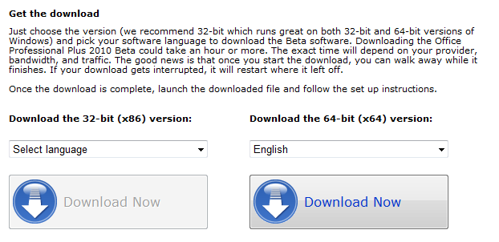

* 1. After clicking download now, you may be promoted to install an ActiveX control for the Download Manager. Choose OK to accept.
  2. Download the installed file named **ProfessionalPlus.exe** to your host machine in a location where it will be accessible to the VM.

1. Install Office Professional Plus
   1. In the VM, navigate to the location of **ProfessionalPlus.exe**
   2. Double click on **ProfessionalPlus.exe** to begin installation.
   3. Accept the default installation options by clicking the **Install Now** button.

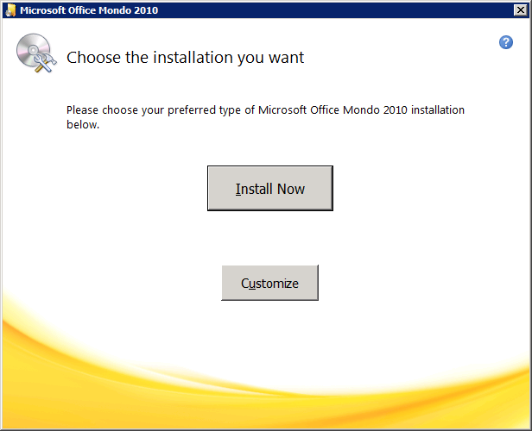

* 1. When installation is complete, you will see the following dialog. Click **Close**.

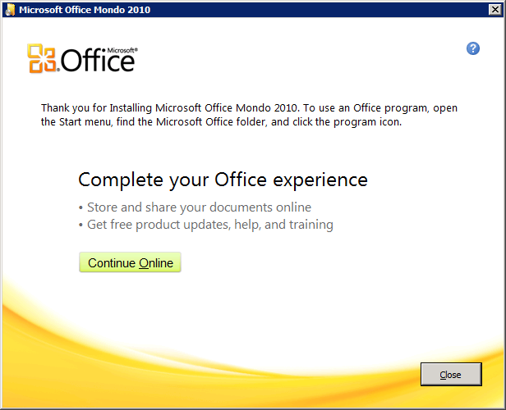

* 1. At this point, it should be quite obvious that installing the Office client is quite a bit easier than installing SharePoint Server 2010!

1. Launch Microsoft Word and make sure it starts without problems.
   1. Start Microsoft Word 2010 from the Windows Start menu.  
      **Start > All Programs > Microsoft Office > Microsoft Word 2010 (Beta)**

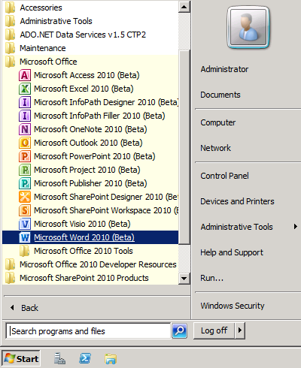

* 1. The first time you launch Microsoft Word 2010, you will see the following dialog. Select **Don’t make changes** and click **OK**.

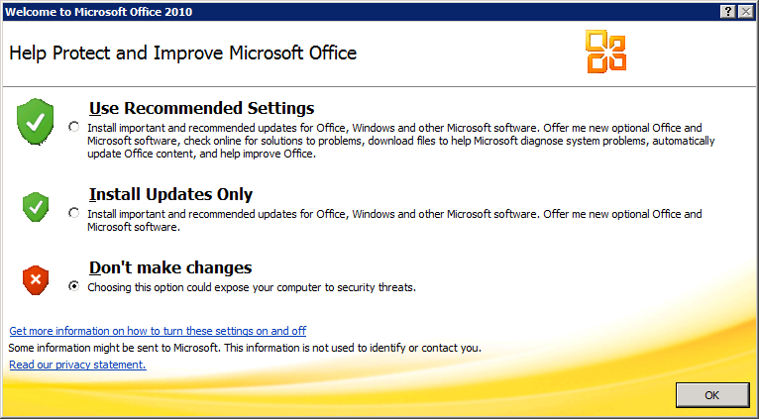

* 1. Close Microsoft Word 2010.

1. Download the SharePoint Designer 2010 Beta 2 installation software from Microsoft
   1. In the browser, navigate to the following URL.

[http://www.microsoft.com/downloads/details.aspx?FamilyID=eeda9ab1-ac53-4870-9e1c-38940343d677](http://intranet.wingtip.com?FamilyID=eeda9ab1-ac53-4870-9e1c-38940343d677?FamilyID=eeda9ab1-ac53-4870-9e1c-38940343d677)

* 1. Click Download to get SharePoint Designer 2010 Beta 2 x64.
  2. Once downloaded, run the **SharePointDesigner_x64.exe** file and install SharePoint Designer 2010.

1. Launch SharePoint Designer 2010 and make sure you can connect to the site at http://intranet.wingtip.com.
   1. Start SharePoint Designer 2010 from the Windows Start menu.  
      **Start > All Programs > Microsoft Office > SharePoint Designer 2010 (Beta)**
   2. Click the **Open Site** button in the top left-hand section of main work area.

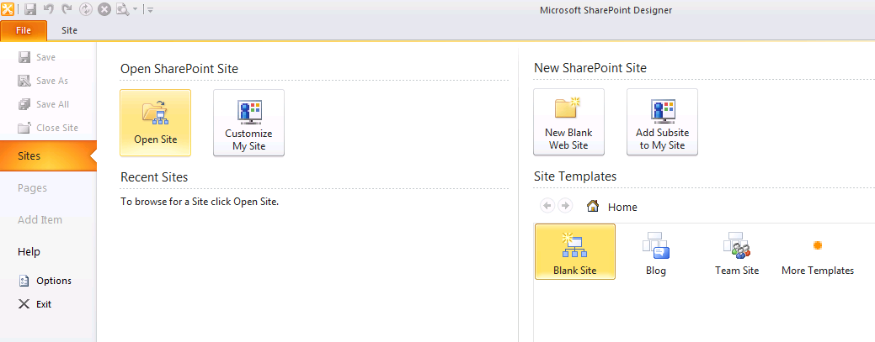

* 1. Open the site at the path of http://intranet.wingtip.com**.** Note that the Open Site dialog can be a bit confusing because it displays all the folders inside the site. All you need to do is enter an URL of http://intranet.wingtip.com in the **Site name** textbox and then click the **Open** button to open the site in the SharePoint Designer 2010.

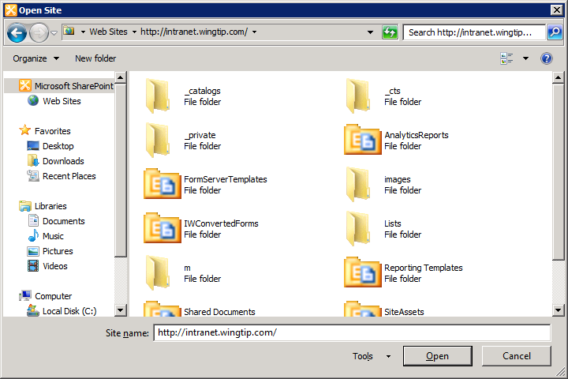

* 1. Verify that the site at <http://intranet.wingtip.com> opened correctly in the SharePoint Designer 2010 and that you can navigate around the various types of SharePoint objects.

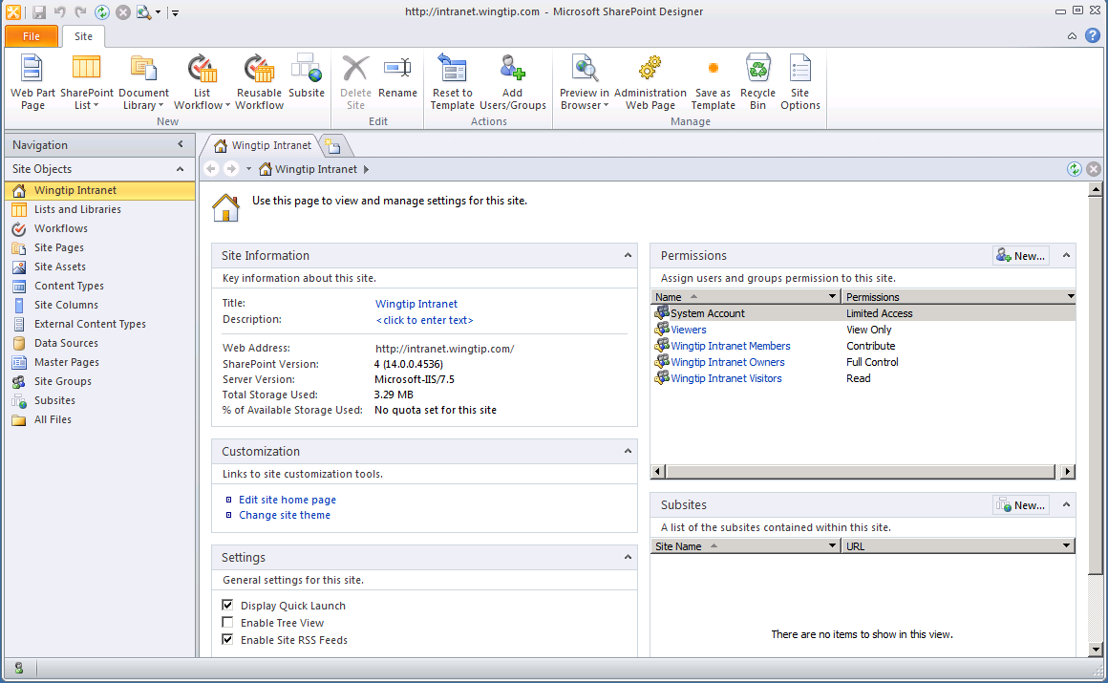

* 1. Close SharePoint Designer 2010.

## Step 9: Install the beta for Visual Studio 2010 Ultimate

In this step you will install the Visual Studio 2010 Beta 2 which includes the SharePoint Tools.

1. Download the ISO file for **Microsoft Visual Studio 2010 Ultimate Beta 2**.
   1. Go to the download page at the following URL

http://www.microsoft.com/downloads/details.aspx?FamilyID=dc333ac8-596d-41e3-ba6c-84264e761b81

* 1. Scroll down to the bottom of the page and locate the **Files in This Download** section. You should see that there are four files that must each be downloaded. Once they are downloaded, you will be able to extract the ISO image.

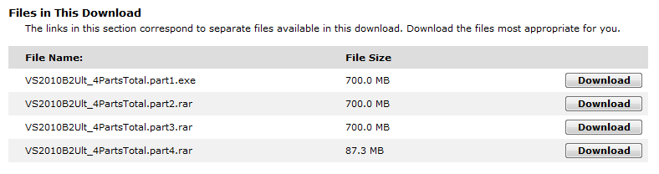

* 1. Download all four files shown in the previous screenshot to a single folder on the file system of the host machine.
  2. In the Windows Explorer, locate the file named **VS2010B2Ult_4PartsTotal.part1.exe** and double click on it to extract the ISO file.
  3. Attach this ISO file to the VM.

1. Install Microsoft Visual Studio 2010
   1. Locate the setup files
   2. Run **setup.exe**.
   3. Click on the link to **Install Microsoft Visual Studio 2010**.

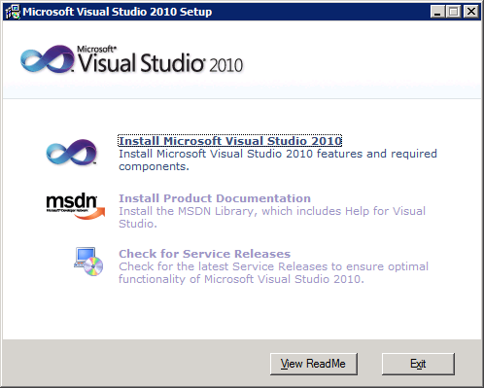

* 1. Click **Next** to move past this dialog.

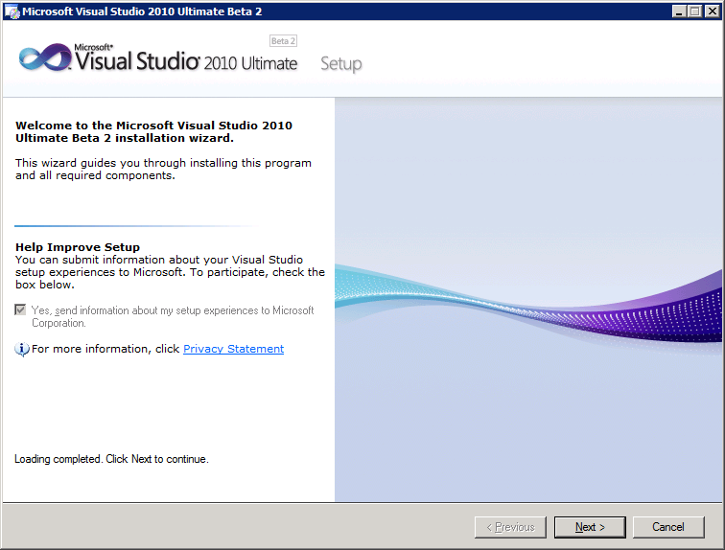

* 1. Select the option **I have read and accept the license terms** and click **Next**.

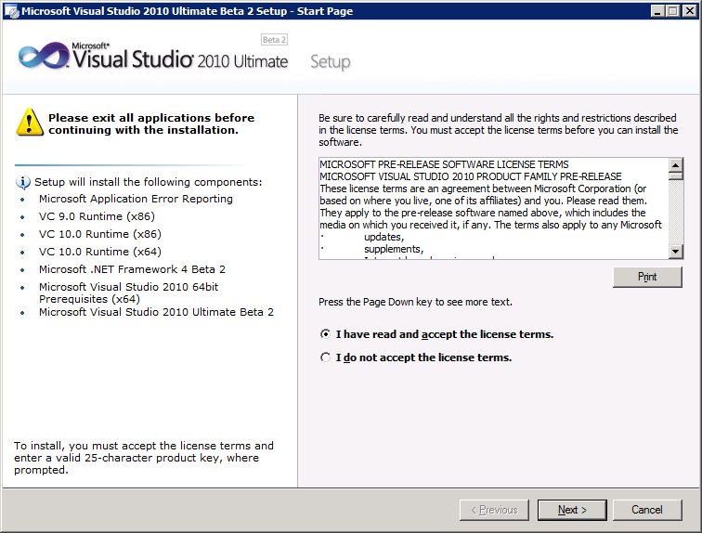

* 1. On the **Select features to install** dialog, select the **Custom** option and click **Next**.

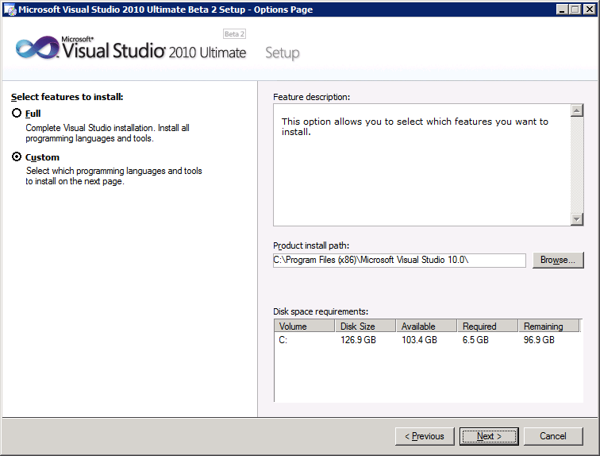

* 1. On the next dialog where you select the features to install, there is only one thing you will change from the default settings. Unselect the checkbox for **Microsoft SQL Server 2008 Express Service**. Unselecting this option is required because the VM already has an installation of SQL Server 2008 Enterprise. If you attempt to install the SQL Server 2008 Express Service, it will cause a failure in the Visual Studio 2010 installation process. Click **Install** to begin the installation process.

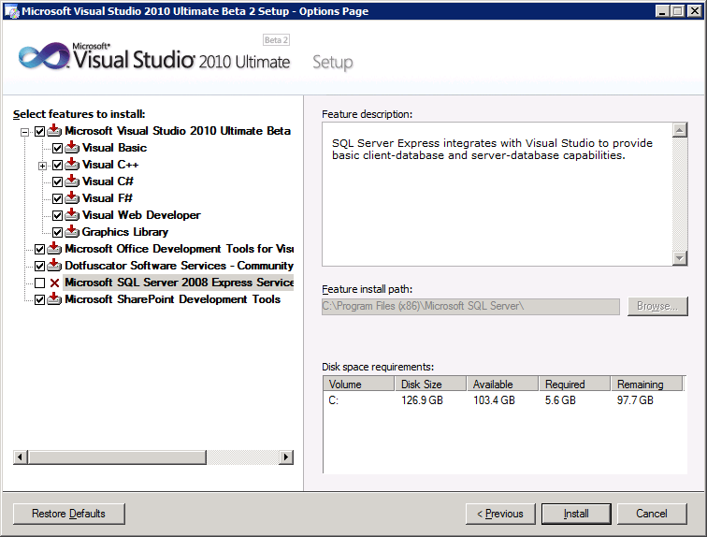

* 1. In the first phase of Visual Studio 2010 installation, the installer program installs a beta version of the .NET Framework 4.0. Afterwards, the installer program asks you to reboot your computer. Click the **Restart** button to reboot the VM.

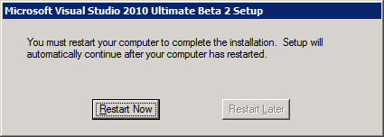

* 1. After the VM has rebooted, log in as **Wingtip\Administrator** using a password of **Pass@word1**. Once you are logged in, the Visual Studio 2010 installation will automatically resume. This second phase of the installation process will take between 10 and 20 minutes to complete. When the installation process is complete, you should see the **Success** dialog. Click **Finish** to end the installation process.

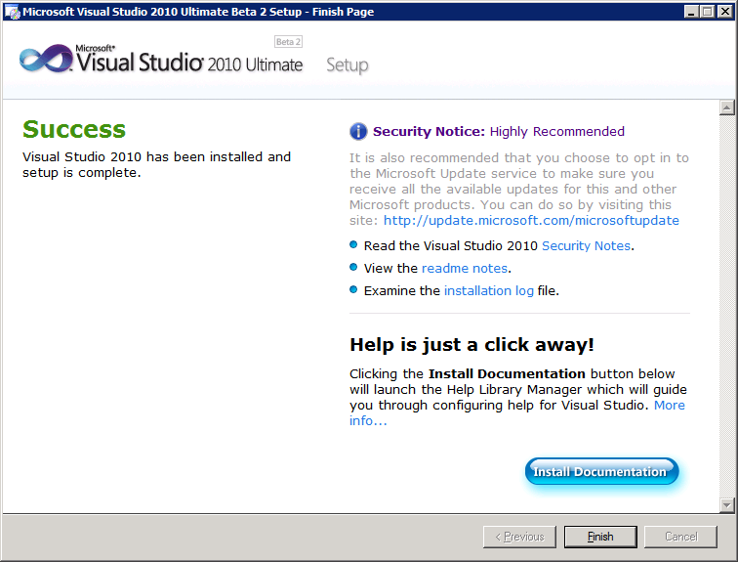

1. Install the Visual Studio 2010 Beta2 SDK.
   1. Go to the following download page for the SDK.

http://www.microsoft.com/downloads/details.aspx?FamilyID=cb82d35c-1632-4370-acfb-83c01c2ece24

* 1. Click the download link to download the installation file named **VsSDK_sfx.exe**.
  2. On the VM, double-click on **VsSDK_sfx.exe** to begin installation of the SDK. When you get to the **Welcome to Setup** screen, click **Next**.

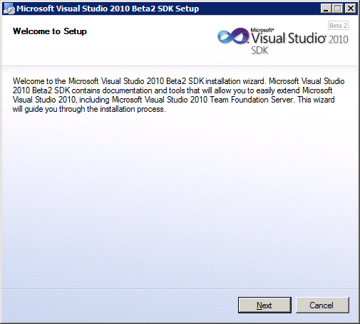

* 1. Accept the terms of the licensing agreement and clock Next.

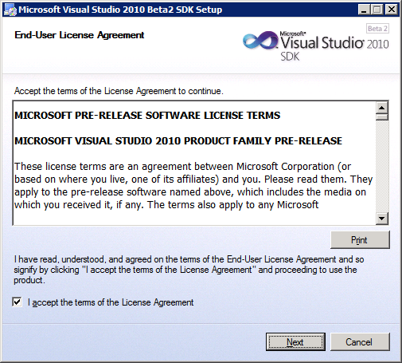

* 1. On the Destination Folder page, leave the folder default setting and click **Next** to start the SDK installation.

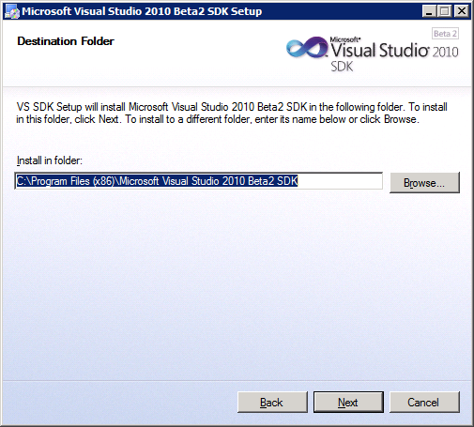

* 1. When you see the Setup Complete dialog, click Exit to finish the installation.

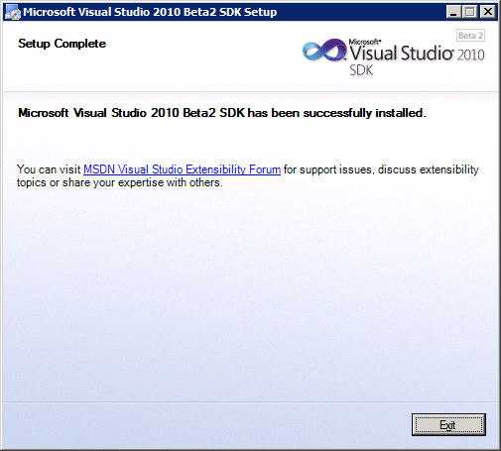

1. Make sure Visual Studio 2010 SharePoint Tools can connect to your SharePoint Farm
   1. Launch Visual Studio 2010 from the Windows **Start** menu.  
      **Start > All Programs > Microsoft Visual Studio 2010 > Microsoft Visual Studio 2010 - ENU**

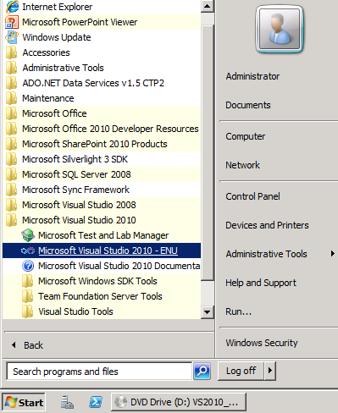

* 1. The first time you launch Visual Studio 2010, it will display the following dialog to **Choose your default environment settings**. Select **General Developer Settings** and then click the **Start Visual Studio** button.

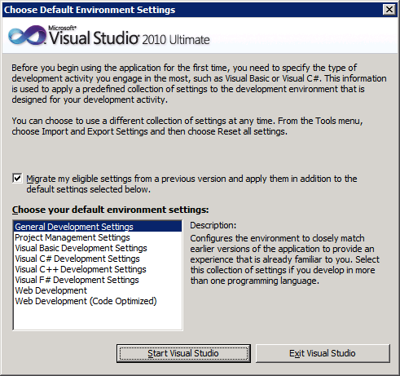

* 1. When Visual Studio starts up, locate the Server Explorer window on the left-hand side of the main window of Visual Studio 2010. If you do not see the Server Explorer, drop down the **View** menu and select the **Server Explorer** menu command.

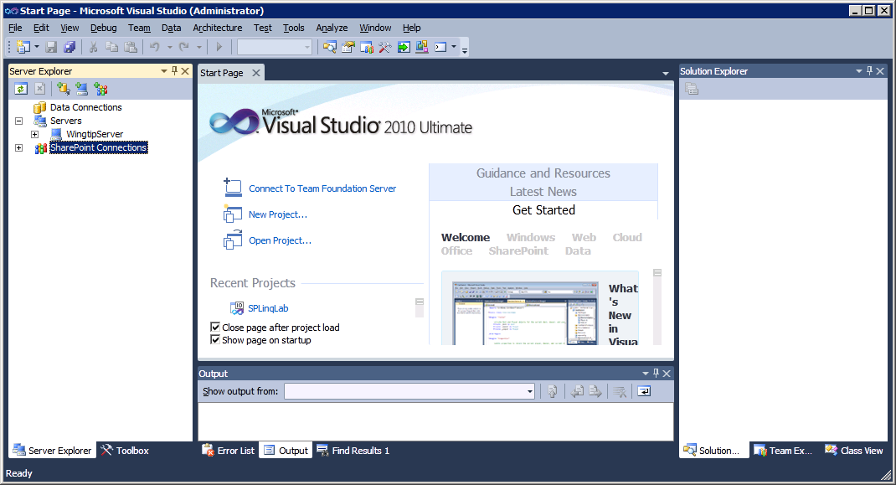

* 1. Locate the right-most button on the toolbar of the Server Explorer windows and click it to add a new SharePoint connection.

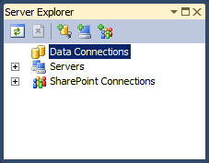

* 1. In the Add SharePoint Connection dialog, enter the URL [**http://intranet.wingtip.com**](http://www.microsoft.com/windowsserver2008/virtualization/install.mspx) and click **OK**.

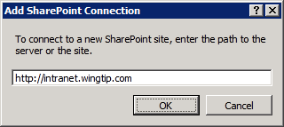

* 1. Verify you can see and drop down nodes within the new connection.

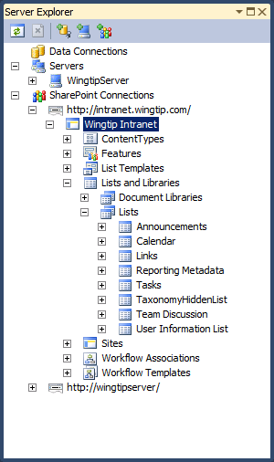

Give yourself a pat on the back. You are now finished with setting up your SharePoint 2010 development VM!